**DTC Art Gallery**

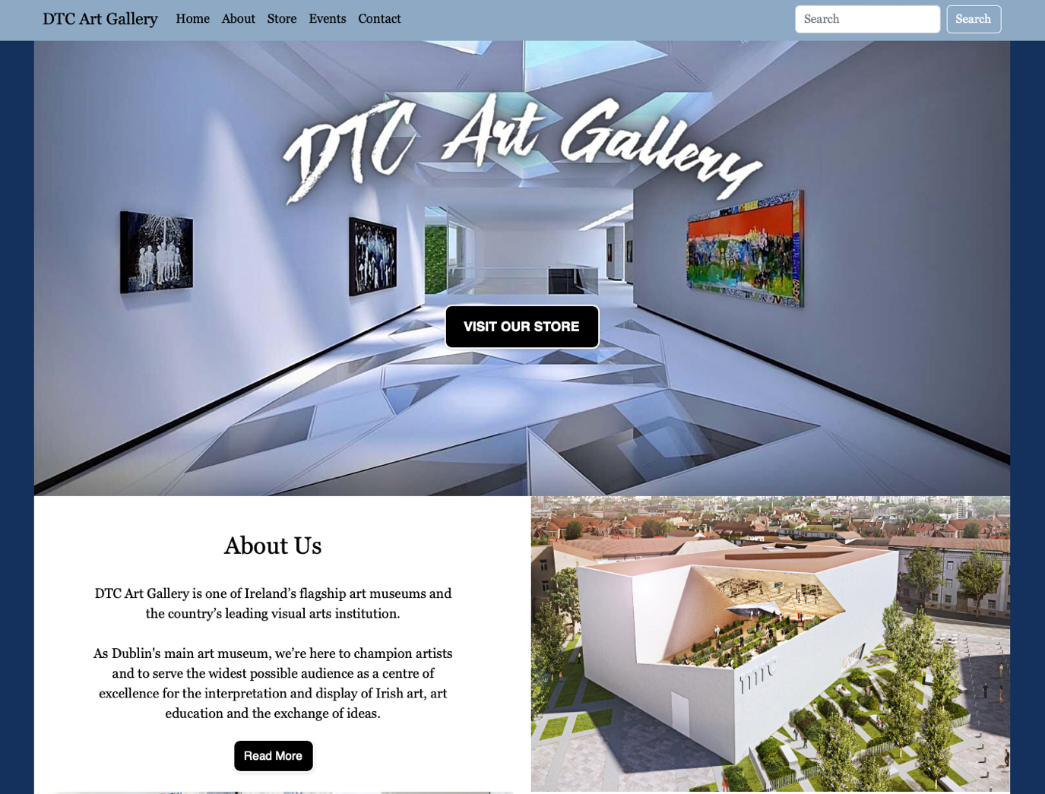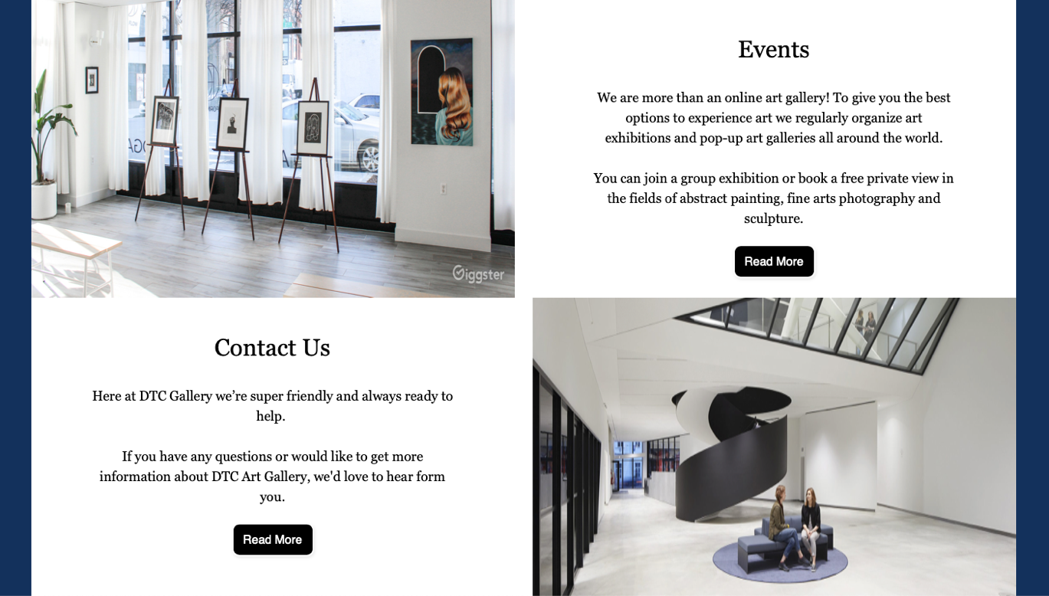

Cormac Wallace  
Dryelen Reis

Tiago Dorigan

**Submitted to:** Fady Anwar

Tuesday 13th of December 2022

Table of Contents

**Executive Summary 3  
Project Work 5**

**Design Process 6**

**Testing & Responsiveness 17**

**Conclusion 59**

**Refences 60**

# Executive Summary

Our business idea is a Dublin based Art Gallery that caters for the widest audience, bringing to the public the opportunity to not only view and experience art in our museum and pop-up galleries, but to connect with likeminded people through or diverse channels. We also offer an auction service to enable our artists to share their work with interested parts.

The focus is to have a website where artists and enthusiast can find all relevant information on the latest pieces, exhibitions, and events, and that can be used as an e-commerce tool to the art pieces.

We decided on this idea because we thought it might be an interesting and unusual business to build a website for. The idea of customers being able to bid against each other for art pieces seemed like a good way to put what we have learned so far into practice.

The market size varies accordingly to the exhibitions, but we estimate around 500k visitors a year, with about half visiting the website before their visits.

Website URL: [DTC Art Gallery (windows.net)](https://tiagodorigannci.z16.web.core.windows.net/index.html) <https://tiagodorigannci.z16.web.core.windows.net/index.html>

Alternative URLs:

<https://tiagodorigannci-secondary.z16.web.core.windows.net/>

<https://dtcartgallery.z16.web.core.windows.net/>

<https://dtcartgallery-secondary.z16.web.core.windows.net/>

# Project Scope

# Within scope

* 6 HTML pages
* CSS Styling for each team member
* Order Form
* Contact us
* A gallery
* jQuery
* Search Engine Optimization
* Content creation

# Out of scope

* High availability
* Disaster recovery
* Security auditing
* Maintenance post-launch
* Search functionality on header section
* Subscribe functionality on footer section
* Process or store information submitted on Contact page
* Add to Watch List functionality on Order page
* Place Bid functionality on Order Page
* User Log In Validation on Order Page

# Assumptions

* SEO is required but no first page ranking
* CDN is going to be implemented using Azure services
* No Connection to databases or back-end servers required

# Project Work Packages

|  |  |  |  |
| --- | --- | --- | --- |
| Work Package | Resource Name | Deliverable | Milestones Description |
| Project Decision | Whole team | Documentation | 1 - System Requirement and plan of action defined so that the development can start. |
| Wireframes | Cormac Wallace | Documentation |  |
| Home Page | Cormac Wallace | Website |  |
| About Page | Dryelen Reis | Website |  |
| Store Page | Cormac Wallace | Website |  |
| Order Page | Dryelen Reis | Website |  |
| Events Page | Tiago Dorigan | Website |  |
| Contact Page | Tiago Dorigan | Website |  |
| Body Styling | Dryelen Reis | Website |  |
| Header Styling | Cormac Wallace | Website |  |
| Footer Styling | Tiago Dorigan | Website |  |
| Colour Styling | Cormac Wallace | Website |  |
| Website Structure Unification | Tiago Dorigan | Website |  |
| Development complete | Whole team | Website | 2 - Development phase completed, website ready for deployment and testing. |
| Website deployment | Tiago Dorigan | Website | 3 - Website deployed. |
| SEO | Dryelen Reis | Documentation |  |
| Testing Report (Validation, Performance, Functionalities) | Tiago Dorigan | Documentation | 4 - Testing completed. |
| Project Report | Dryelen Reis | Documentation | 5 - Report completed and ready for submission. |

# Design Approach

Workflow Chart – Map the project steps.

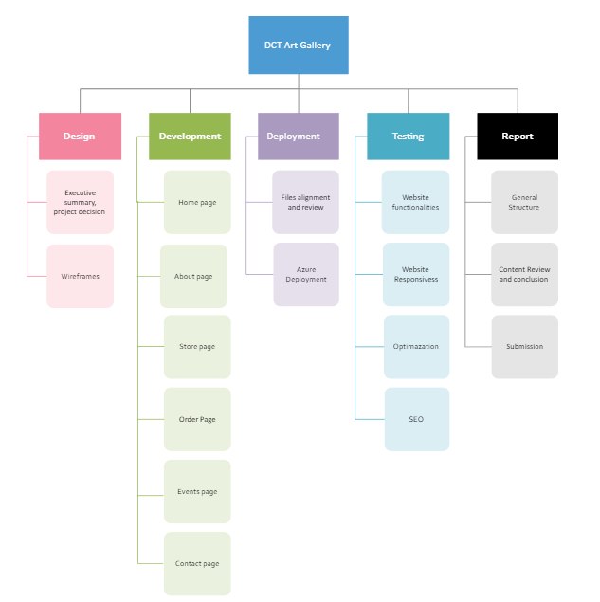

User Flow Chart – Map the navigation through the website pages.

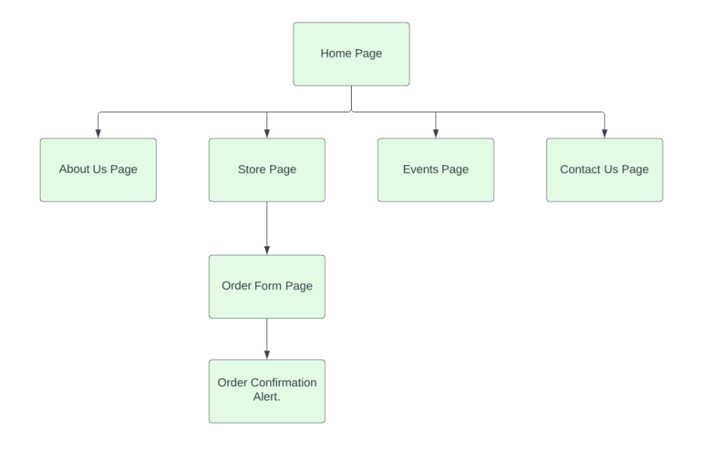

# Design Process

**Colour palette:**

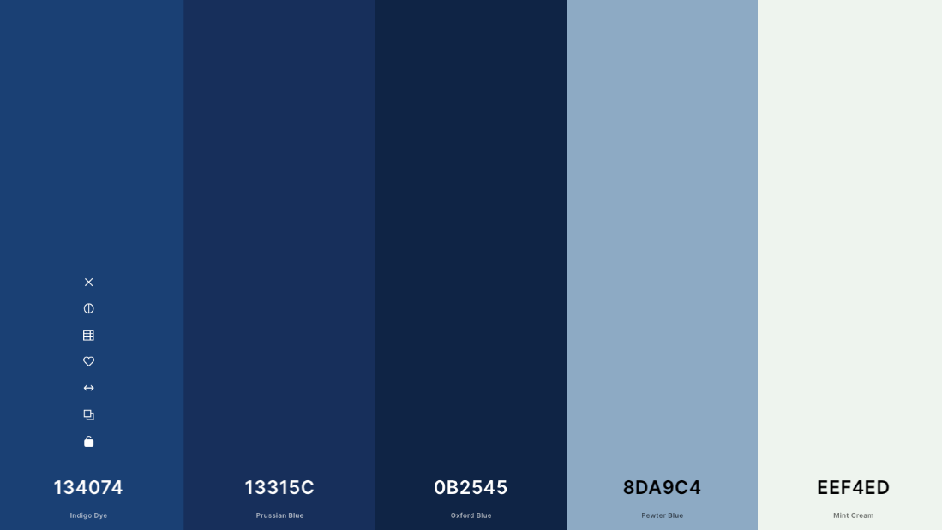

**Fonts used:**

font-family: Georgia, 'Times New Roman', Times, serif.

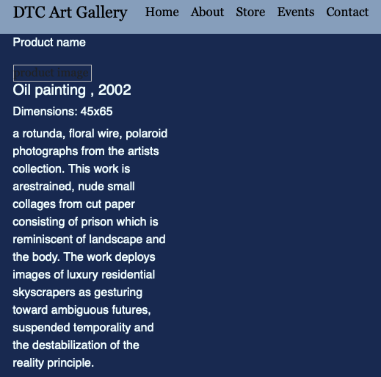

**Buttons used:**

Home page buttons: Black and white styling. Although not strictly part of our colour palette Black and white can fit any theme if used correctly. The black and white buttons add to the modern look of the gallery.

 

About page buttons: Social media color icon. Used to call attention from visitors and increase visits on social media channels. Redirects visitor to social media website.



Subscribe standard button. Submit email address to mailing list (fictional function, as no database connection established), alert window displaying “Subscription Successful.”



Store page buttons : Light blue styling, same color as the navigation bar. Color is included in our color palette so it fits our theme.

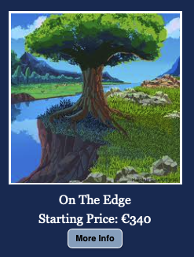

Order page buttons: Check type label. Alert window displaying “Added to Watch List.”

Primary button styling. Opens a modal containing login form.

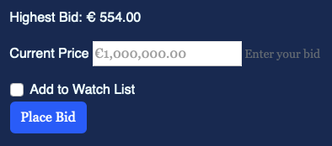

Login form buttons:

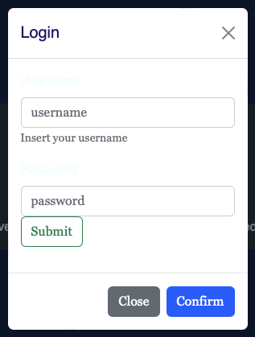

Confirm: Primary button styling. Alert windown displaying “Bid Placed”.

Close: Secondary button styling. Closes the login form.

Submit: outline-success styling. Alert windown displaying “Login sucessful”.

Events page button: Add to Calendar Button to add event on chose calendar.

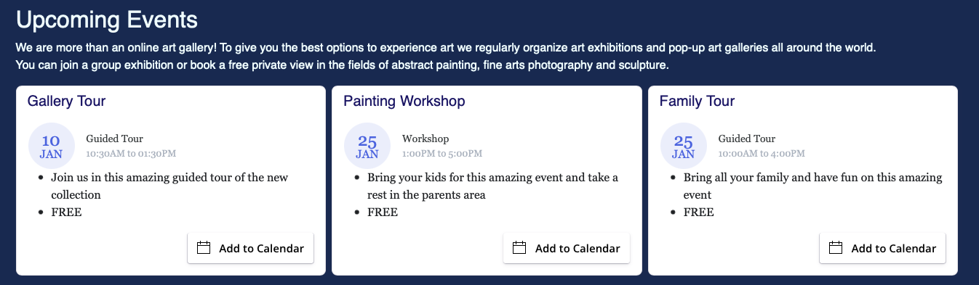

Contact page button: Primary button styling. Send message for the website administration (Out of scope function).

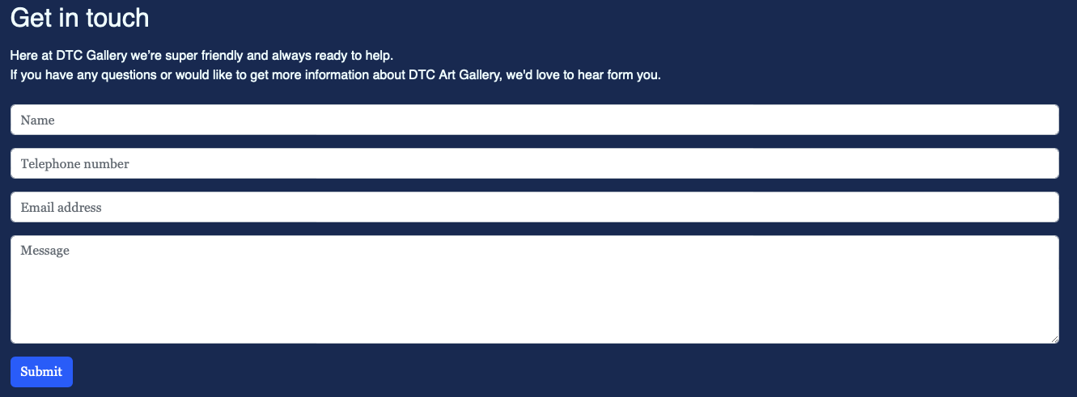

**Wireframes**

Home Page

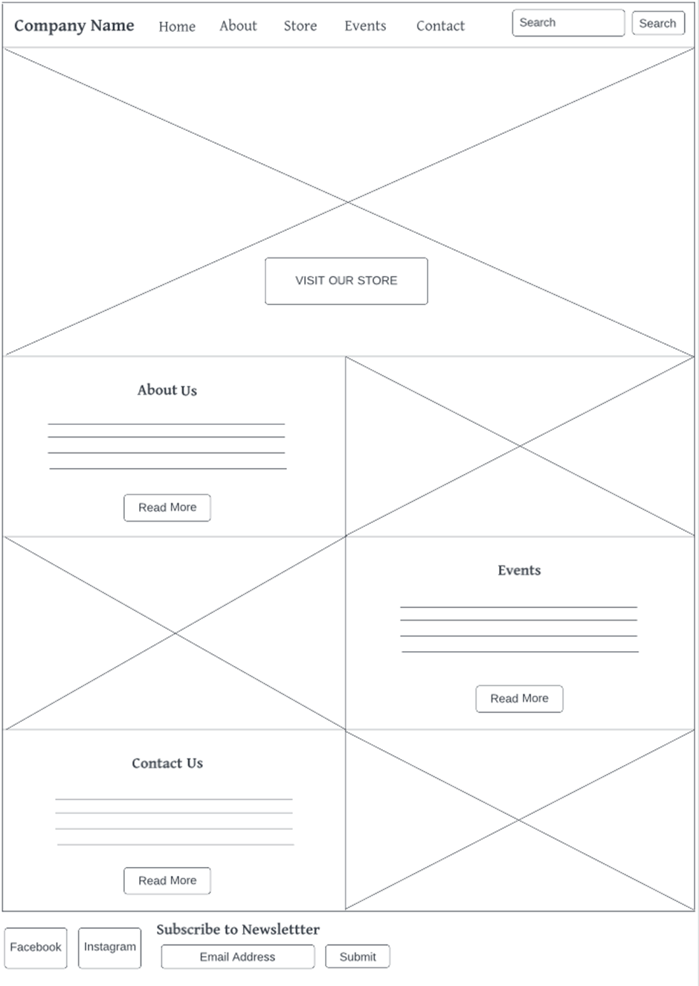

About

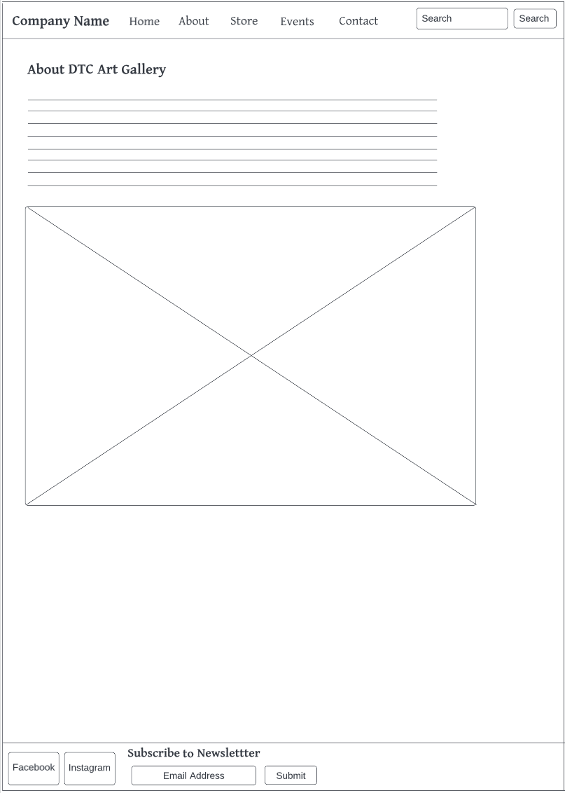

Store

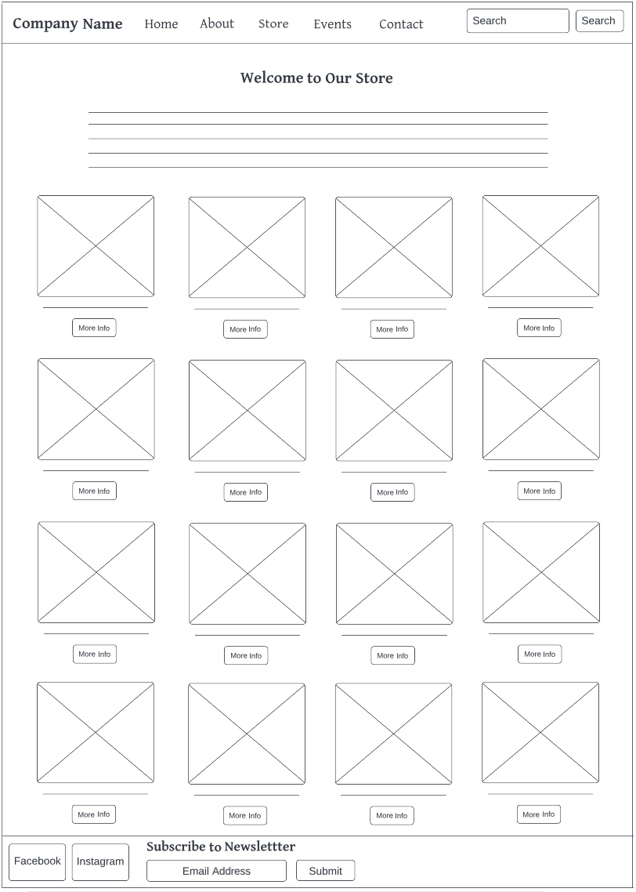

Order

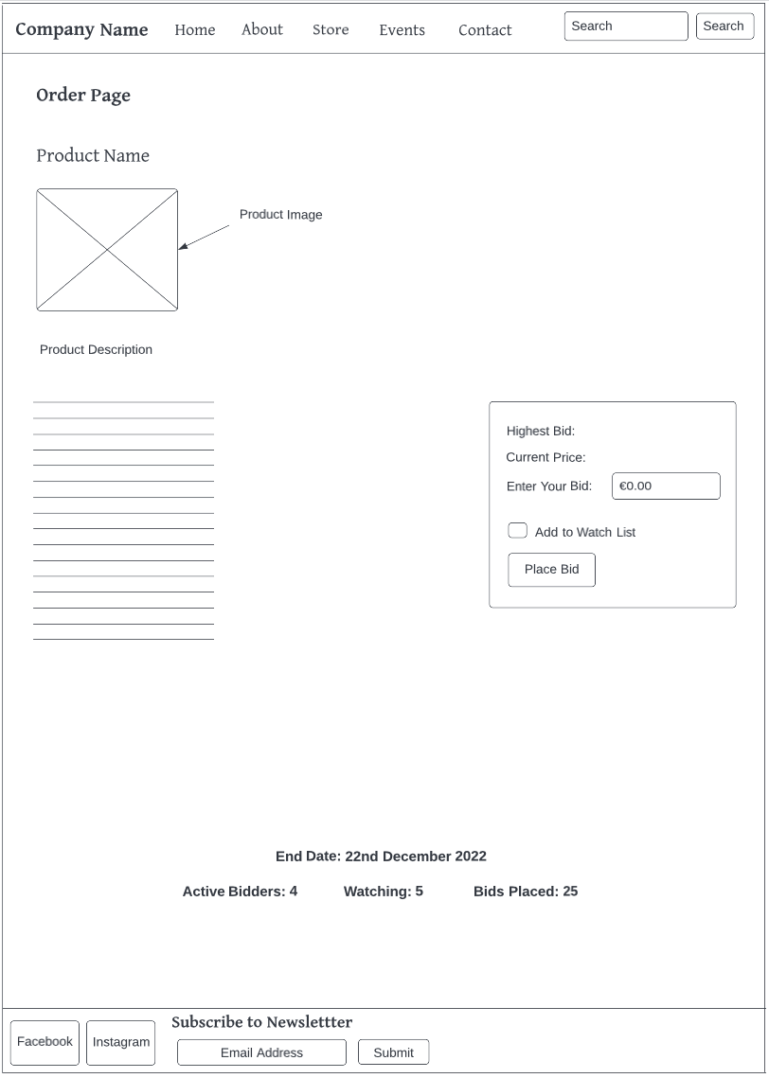

Events

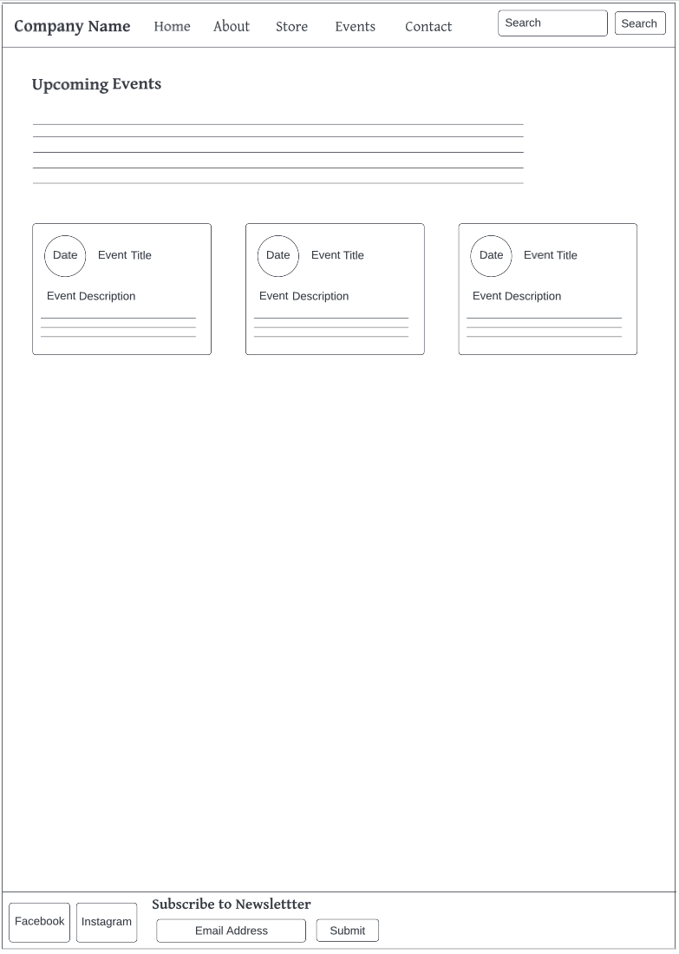

Contact 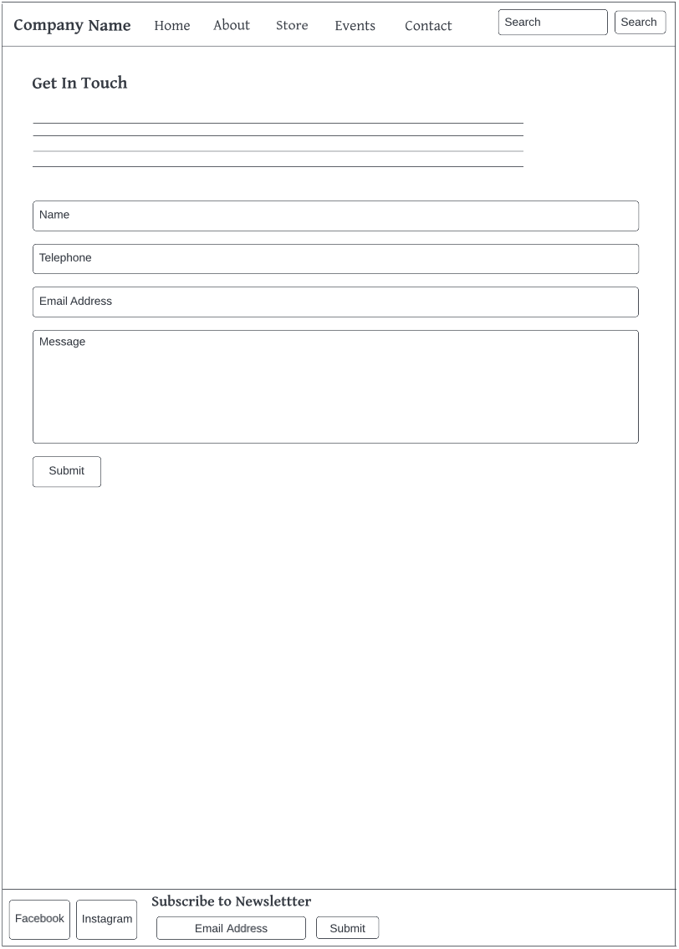

# Testing & Responsiveness

**Website responsiveness**

Achieved using bootstrap, wireframes created using containers.

* **Browsers**

Chrome, Edge, Firefox and safari are loading on the same format as below:  
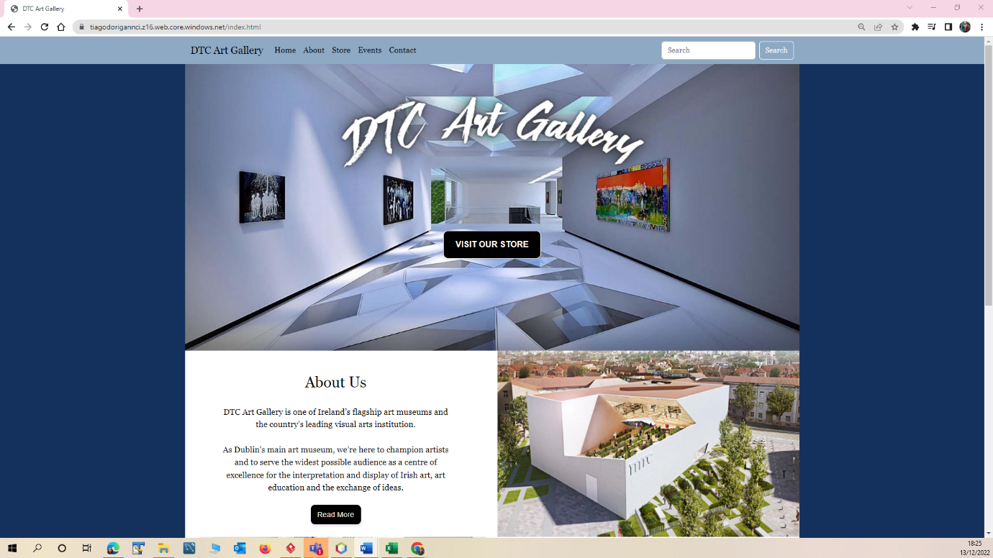  
  
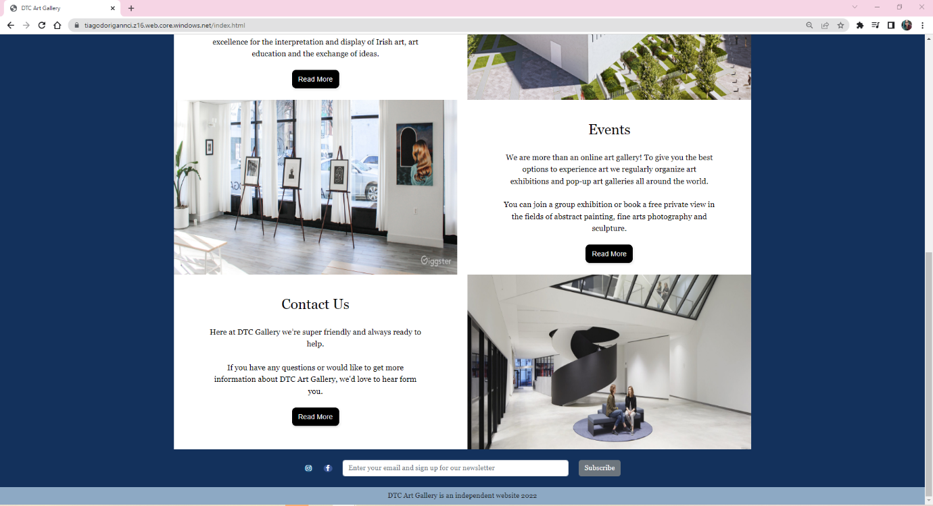

* **Screen sizes:**

Laptop/desktop screen

Home:  
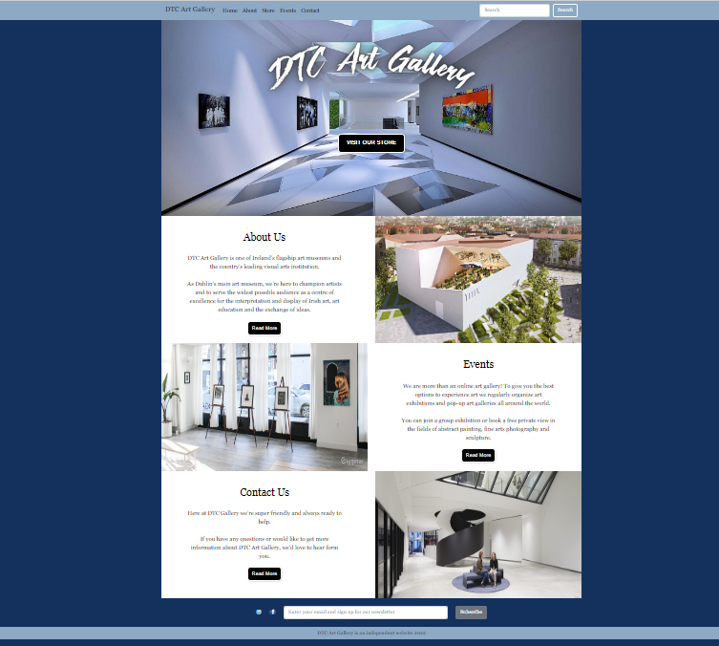

About:  
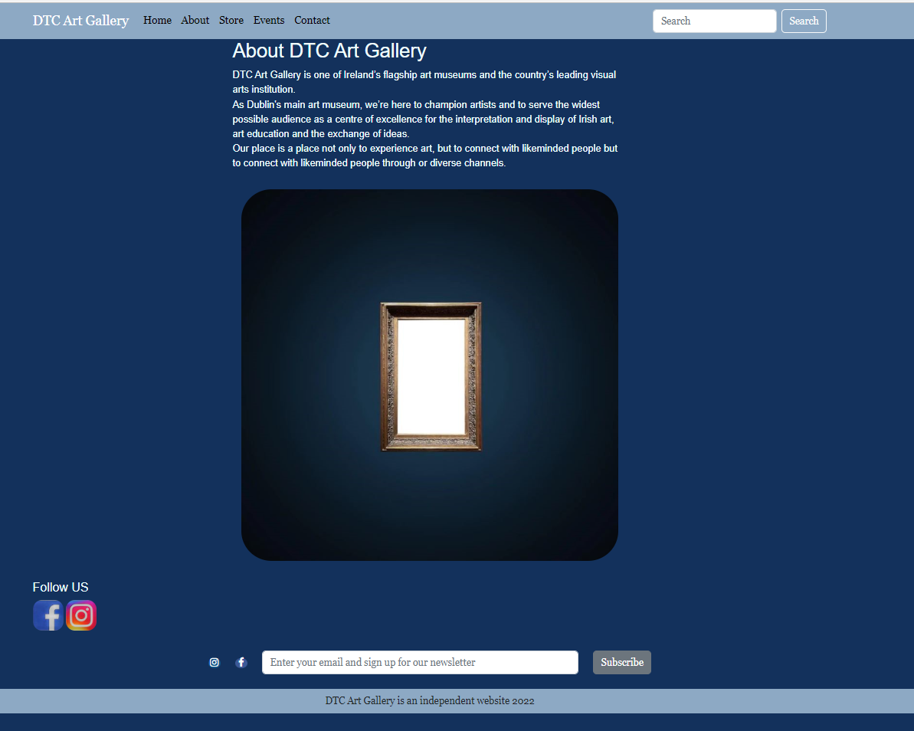

Store:  
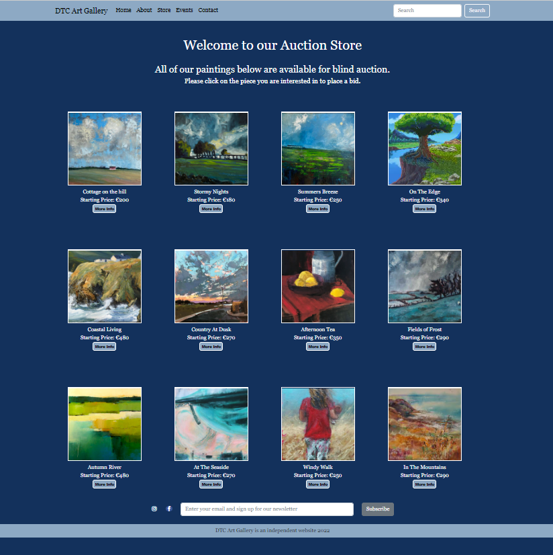

Bid:

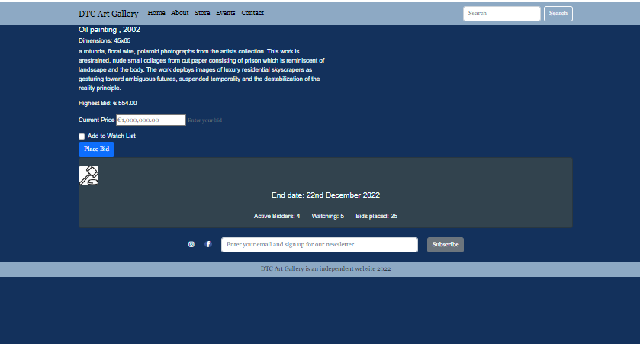

With modal open

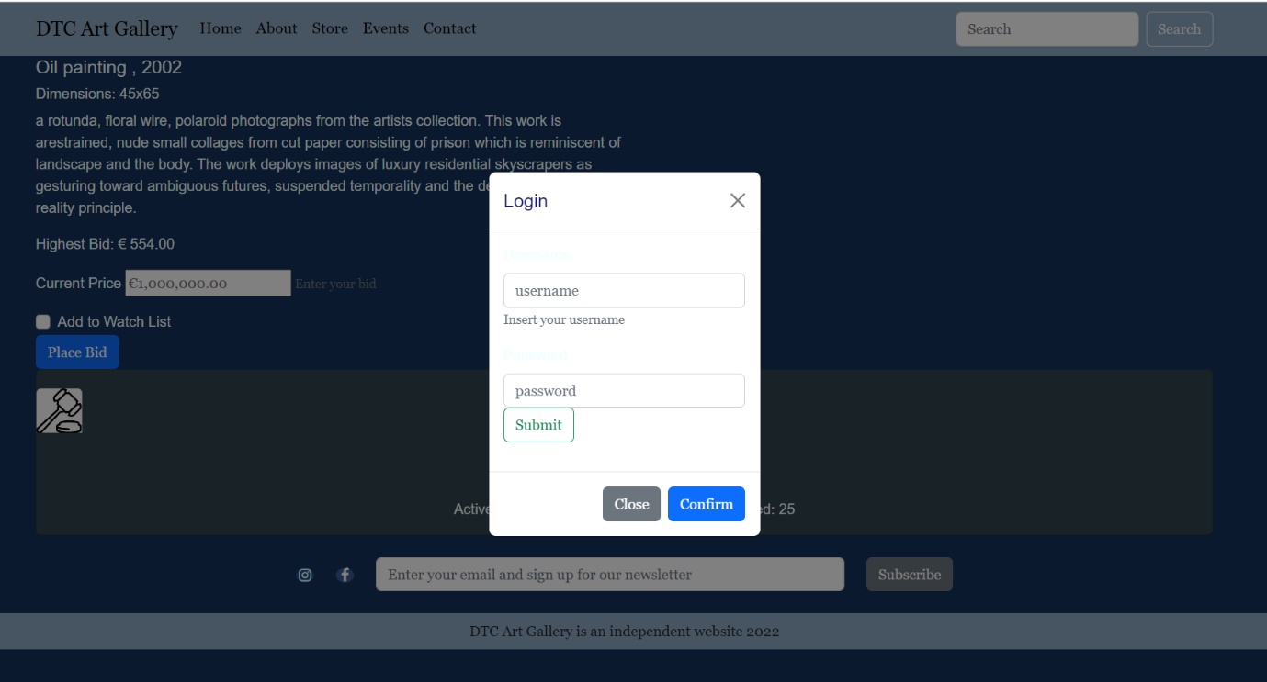

Events:

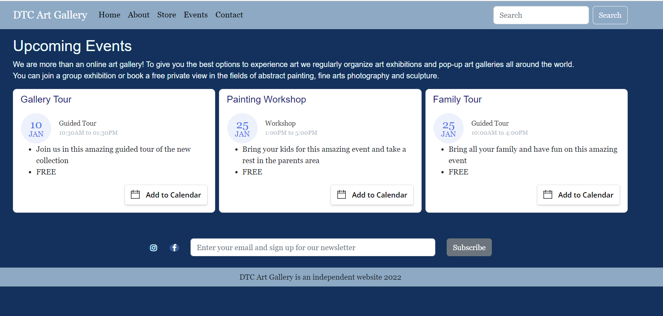

Contact:  
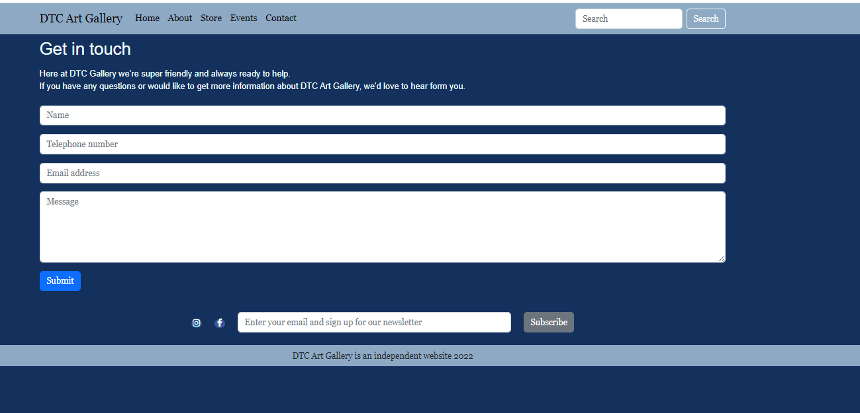

iPad screen   
  
Home: Pictures and text are stacked. Navigation bar and footer stay the same.

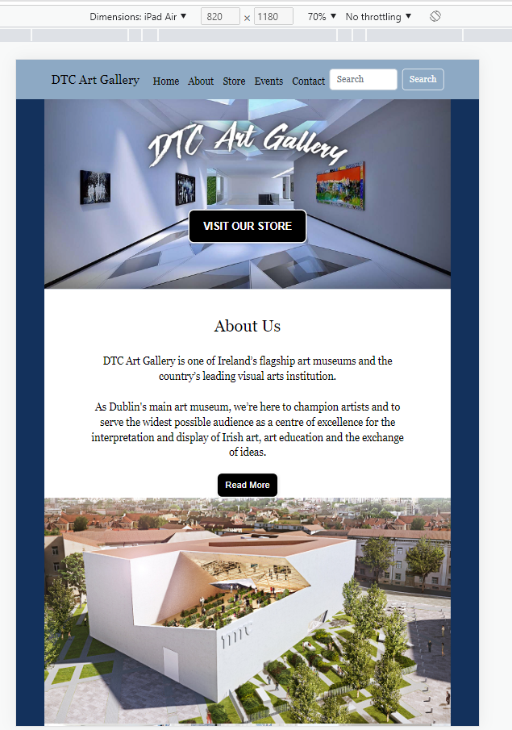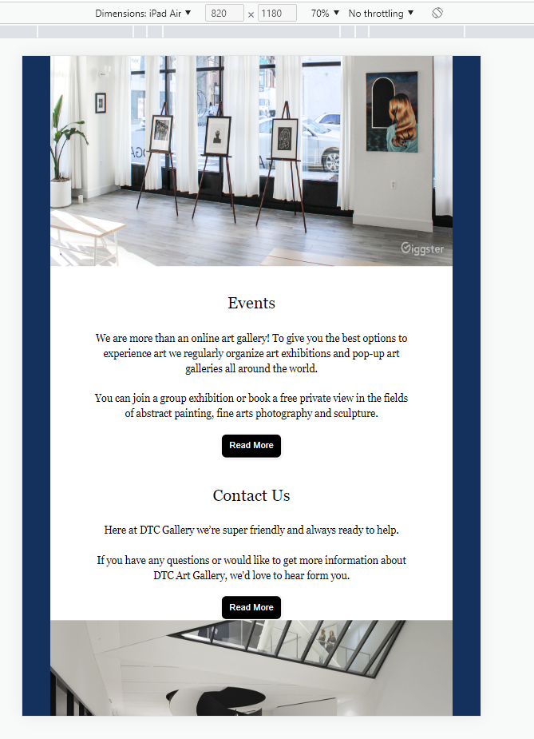

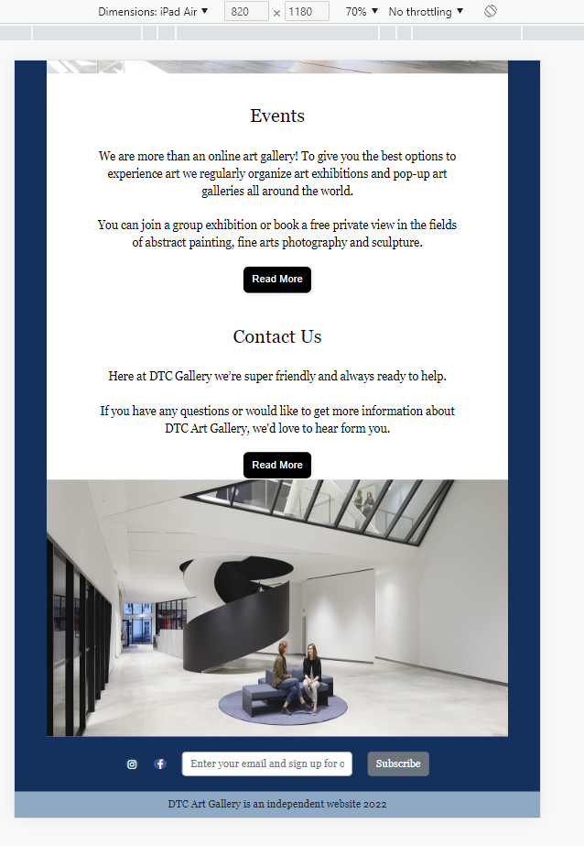

About: Same layout as the desktop.

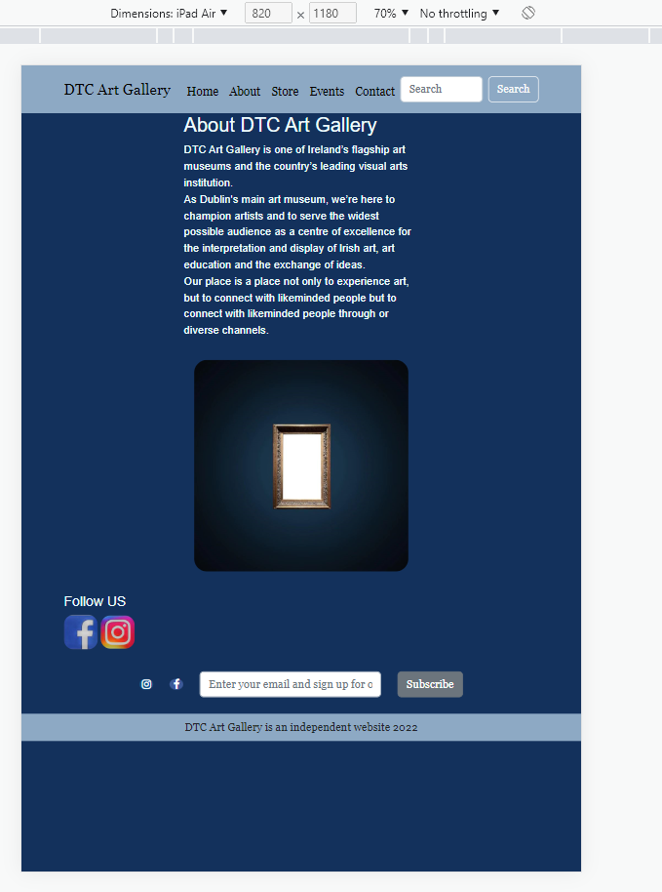

Store: Pictures overlapping instead of stacking - issue logged (Id 15) - Navigation bar and footer stay the same.  
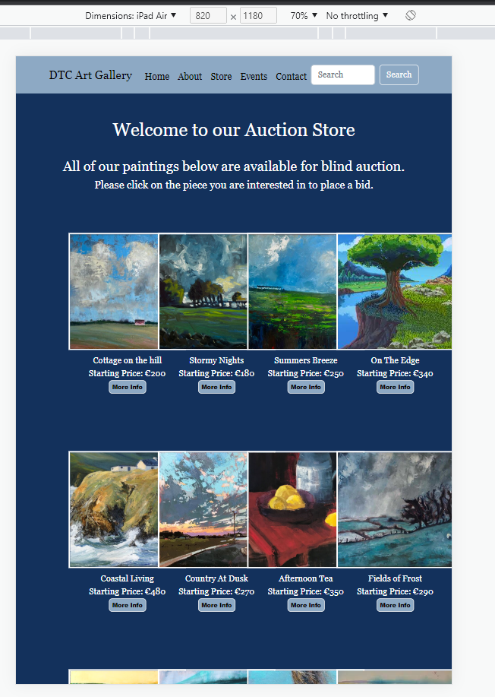 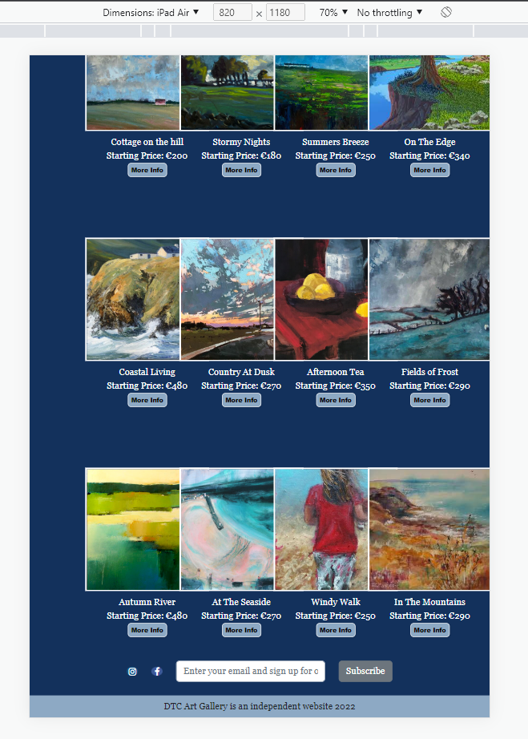

Bid: Same layout as the desktop.  
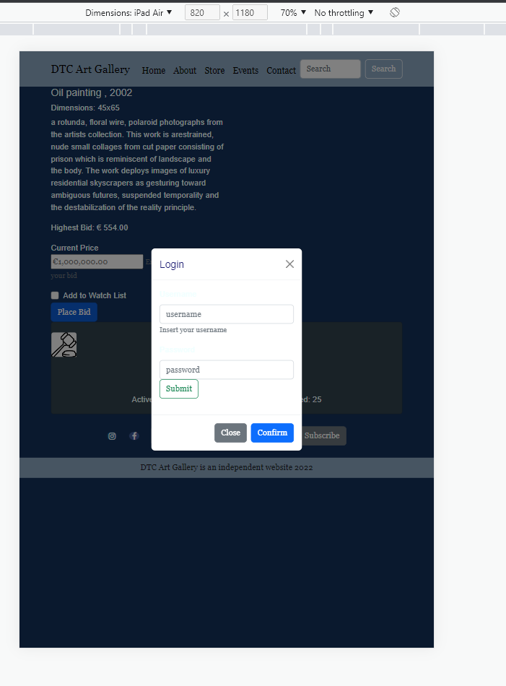

Events: Cards stacked to better visibility. Navigation bar and footer stay the same.  
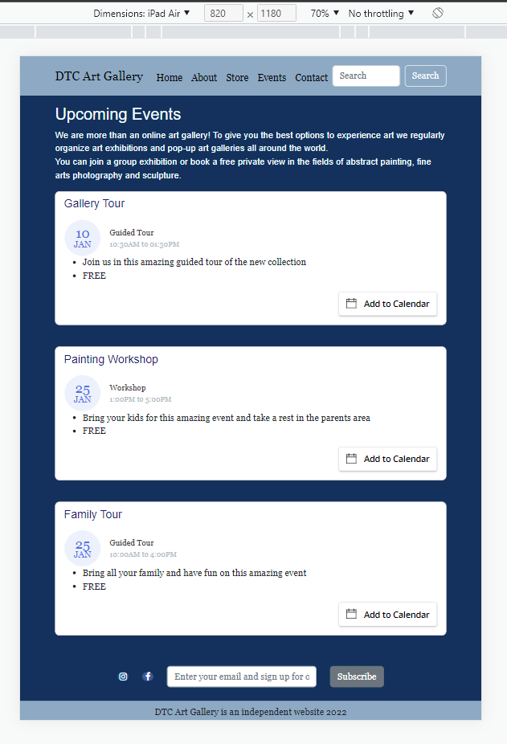

Contact: Same layout as the desktop.

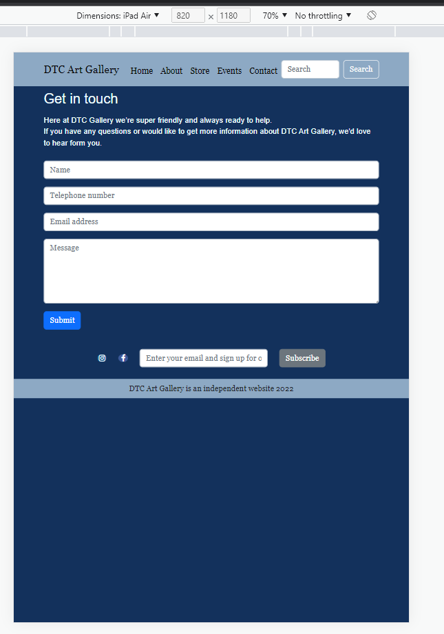

iPhone

All pages completely resized for better visibility. Navigation bar, body and footer stacked.   
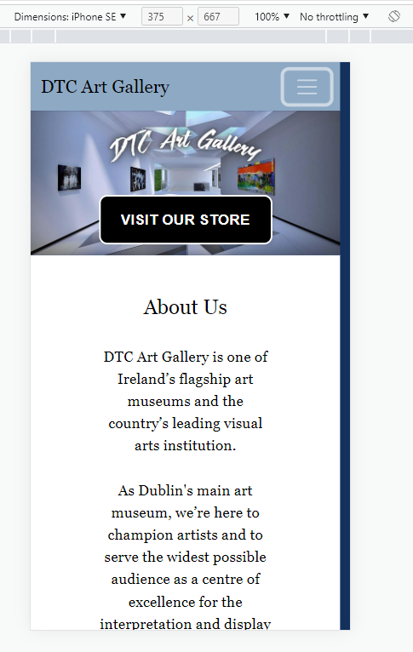 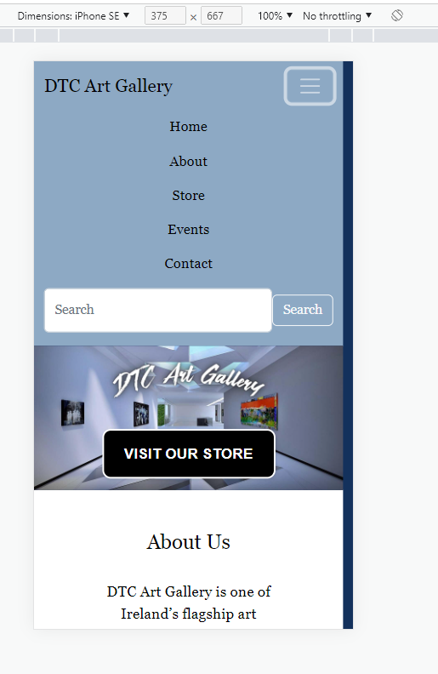  
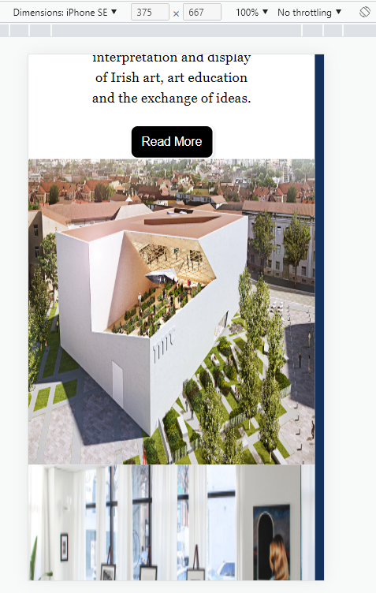 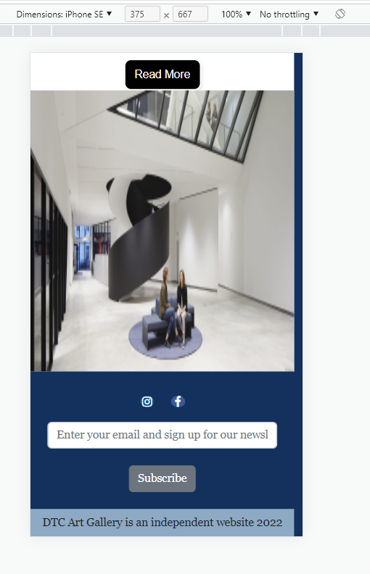

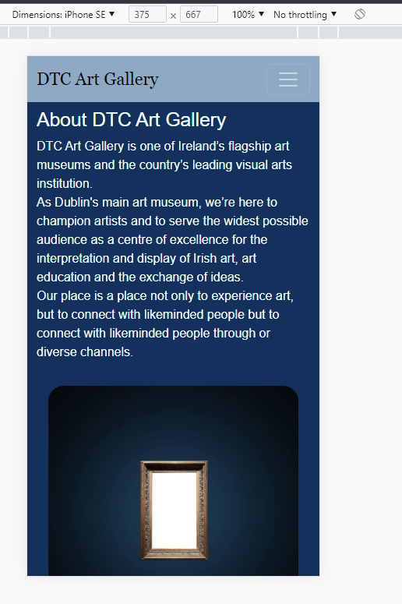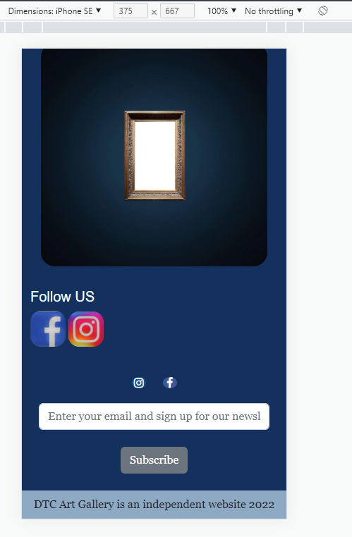

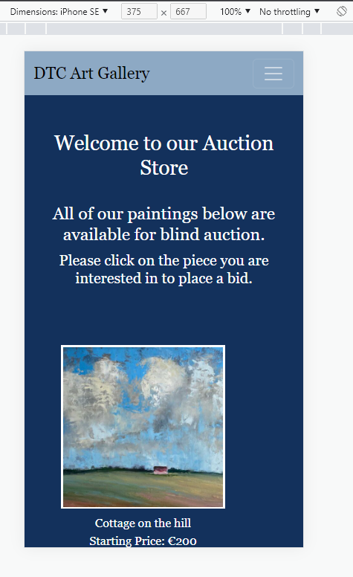 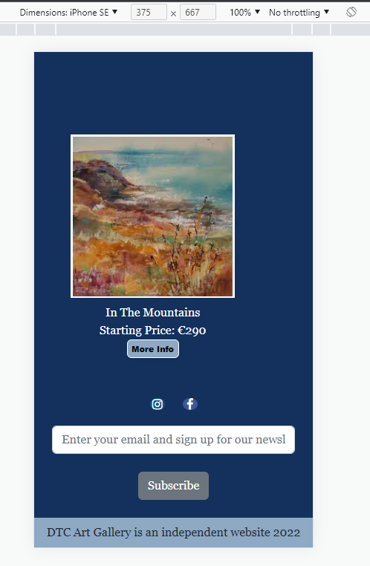

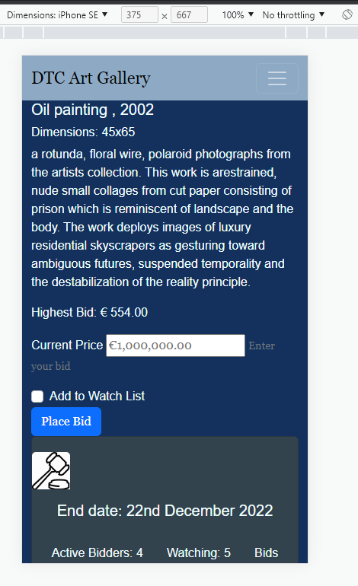 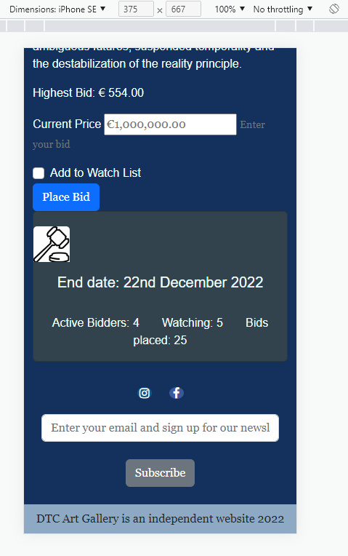

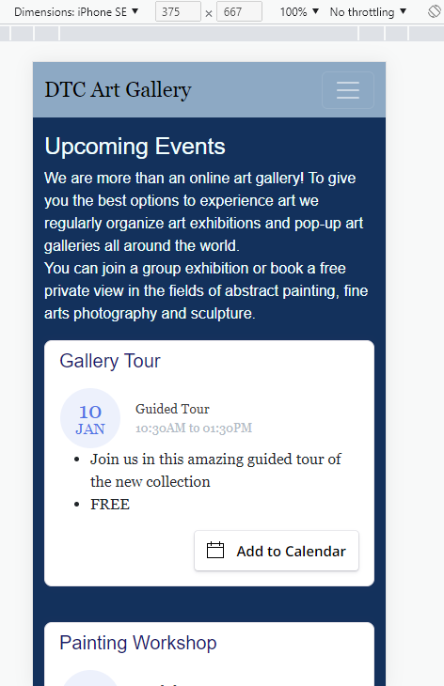 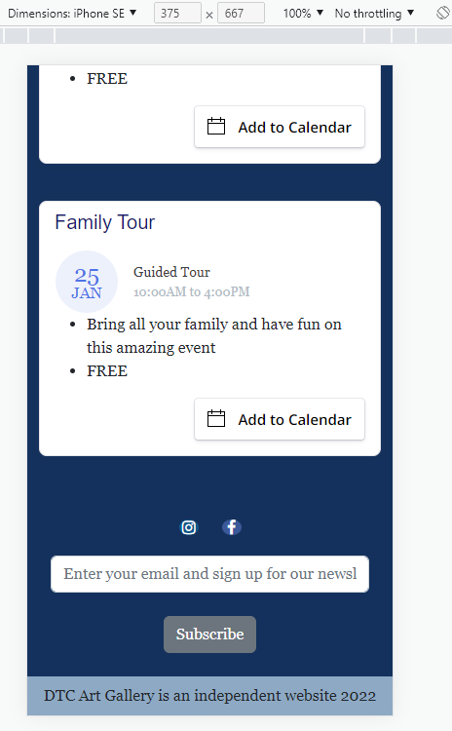

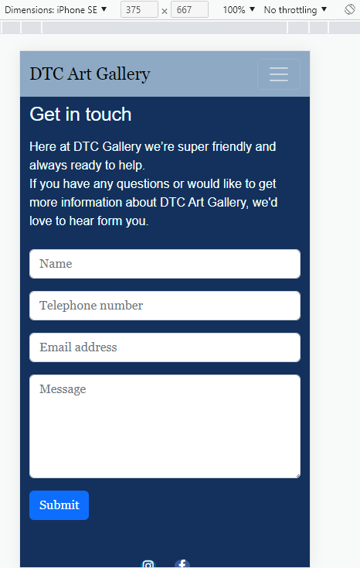 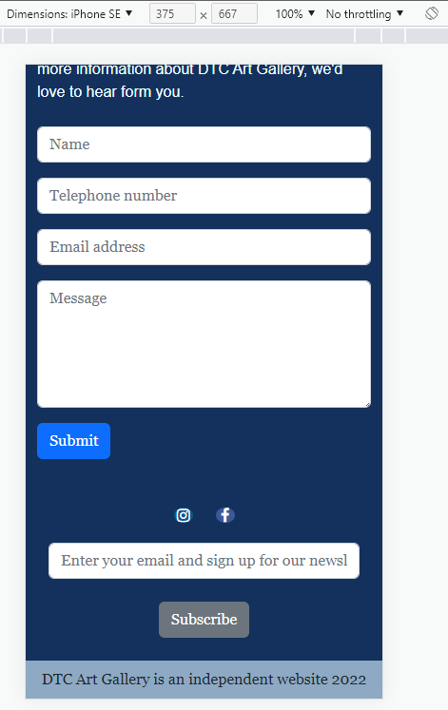

JavaScript functionalities

Functionalities applied to redirect visitors to another page, display alerts, open modals and submit forms.

If statement used to confirm message to be submitted on contact pages.

**Deployment**

The website deployment was done on Microsoft Azure, where we created and configured a Storage Account, a Resource Group, and a Static Website.

Storage Account

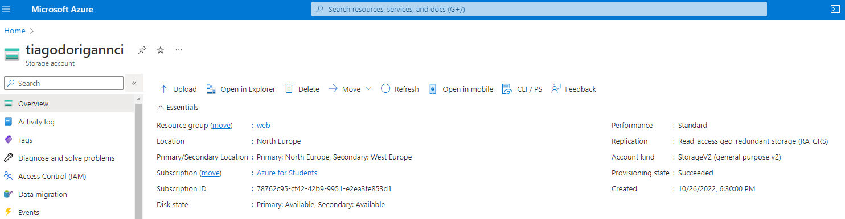

Static Website

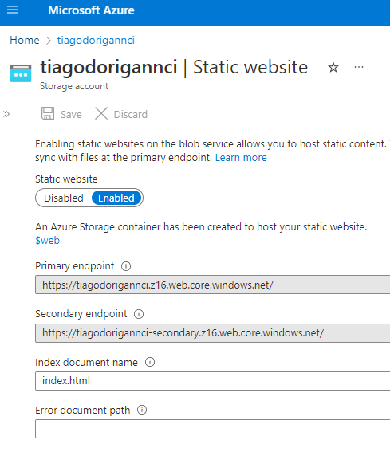

Container

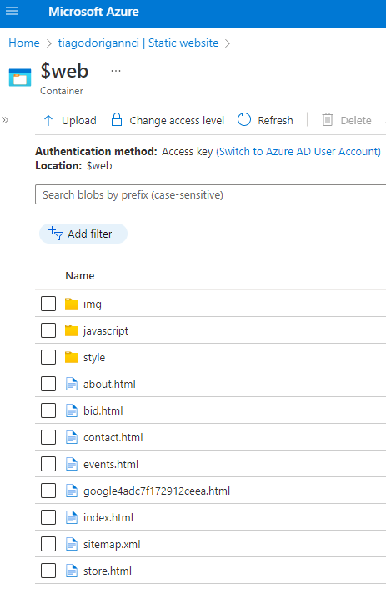

**Search Engine Optimization**

* Paid vs. Organic traffic – Our website is relaying on organic traffic, meaning no add campaign is live for it, however we used some of the key words suggested by google to help with our SEO.
* Google's keyword plan – Used suggested keywords from google ads + keyword plan toll + search keywords.

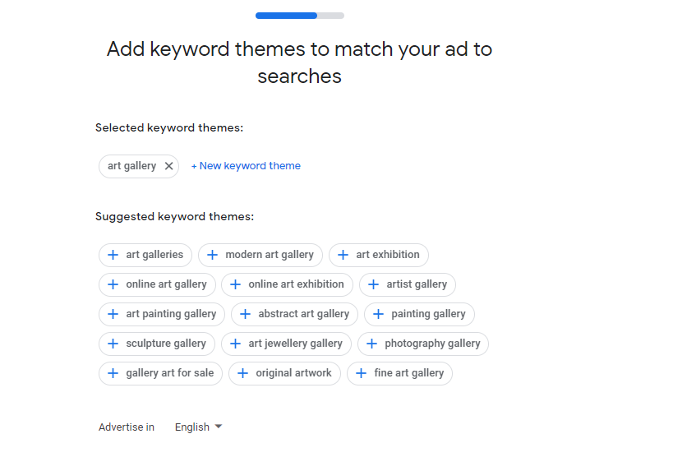

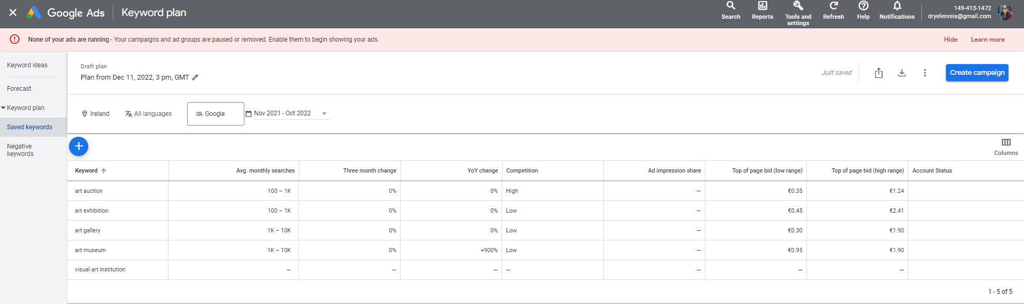

* Targeting search keywords, using most searched related titles to rank up the pages

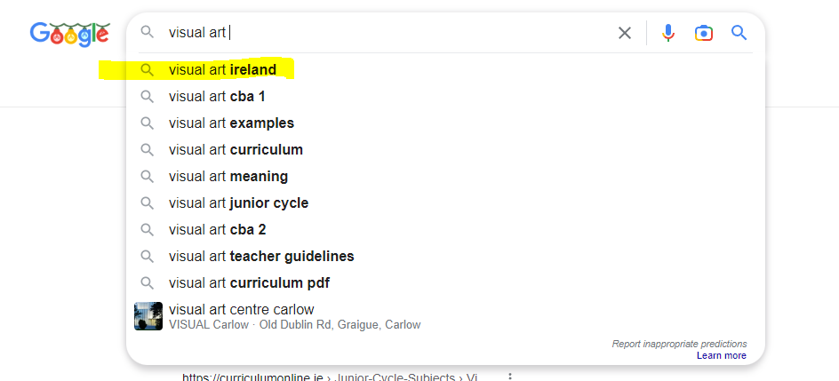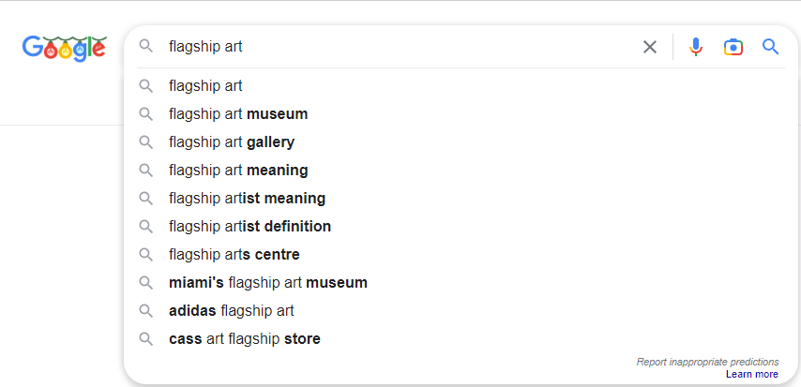

* [Google Search Console](https://mymoodle.ncirl.ie/mod/url/view.php?id=37136)

Ownership verified using a meta tag.

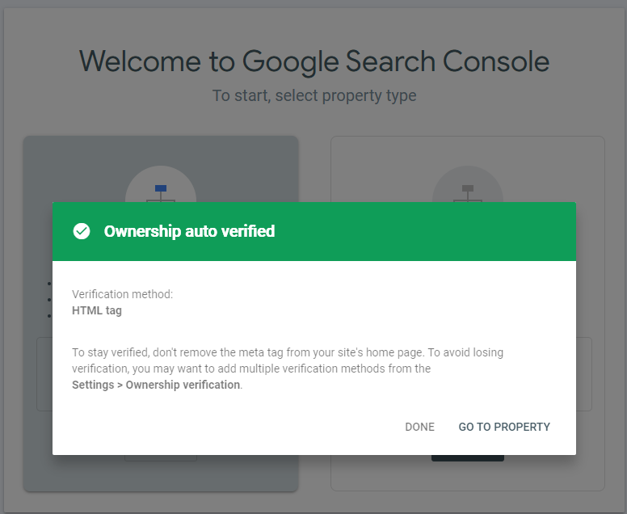

Live test concluded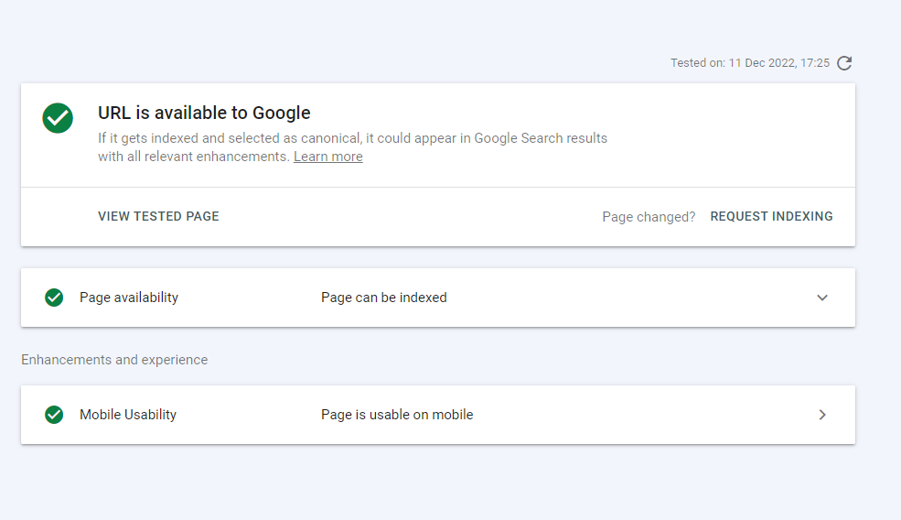

No issues with resources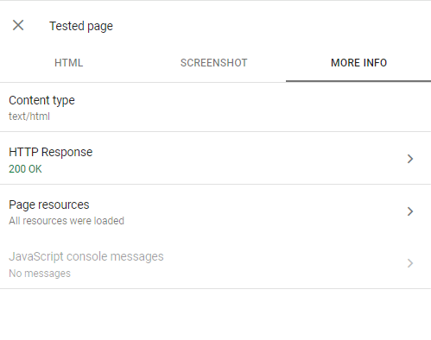  
Page indexed on Google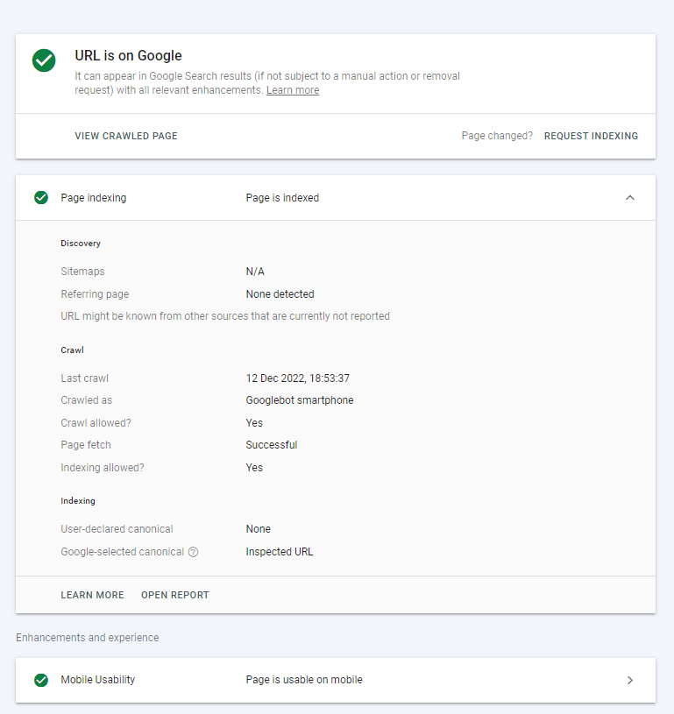

Google search – first result  
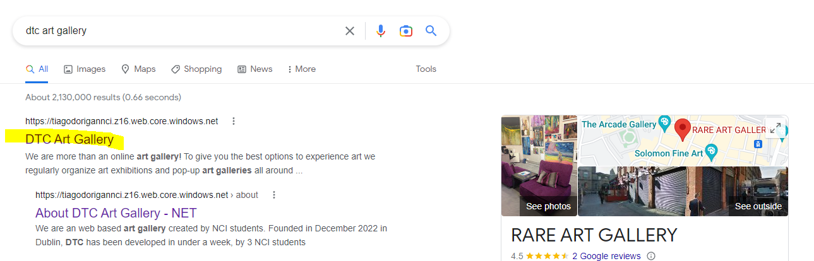

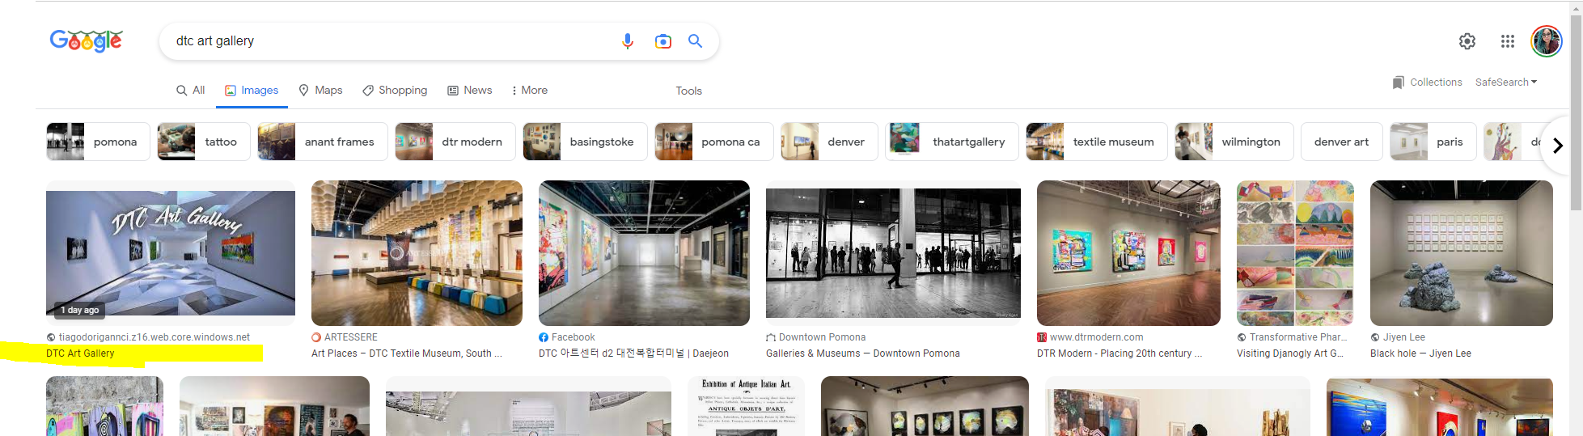

* [Google Analytics](https://mymoodle.ncirl.ie/mod/url/view.php?id=37135) real time overview  
    
  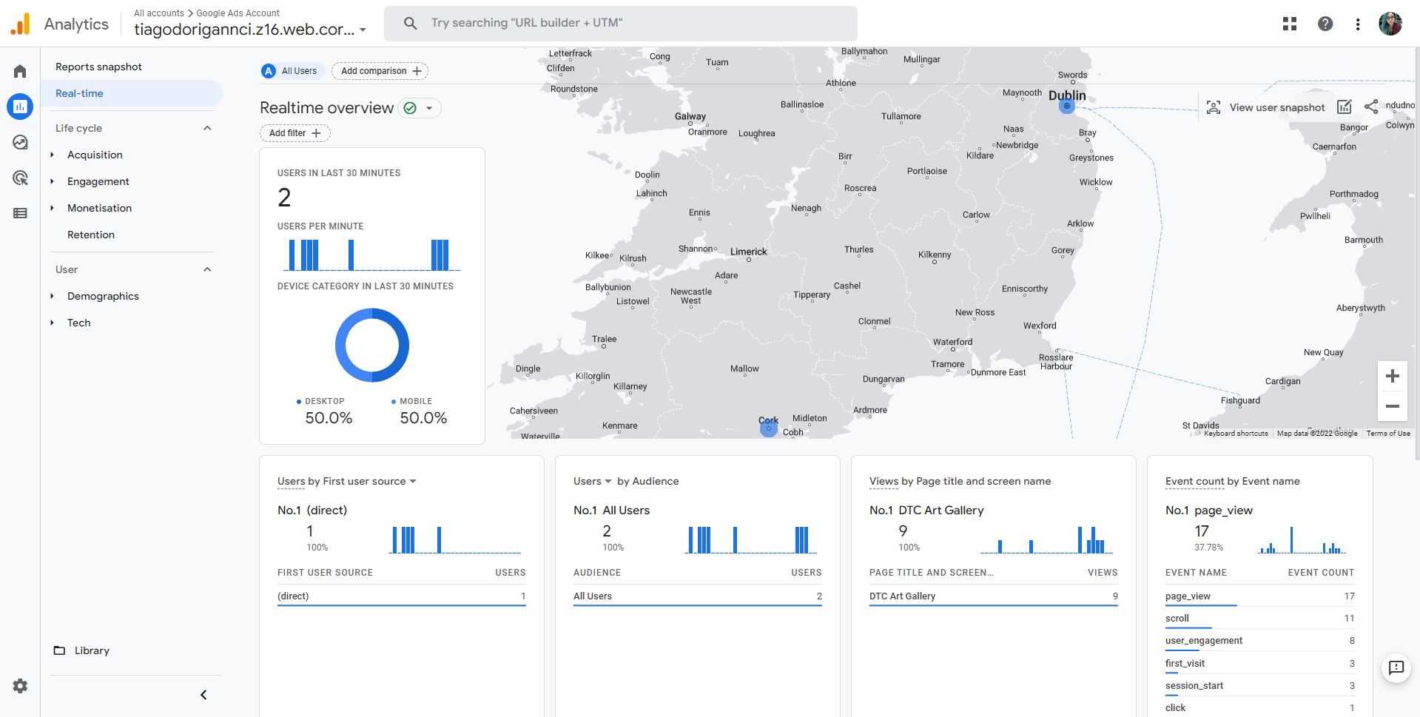

**Optimization**

We used HTML validator (<https://appdevtools.com/html-validator>) to validate and catch bugs on our html pages.

About page

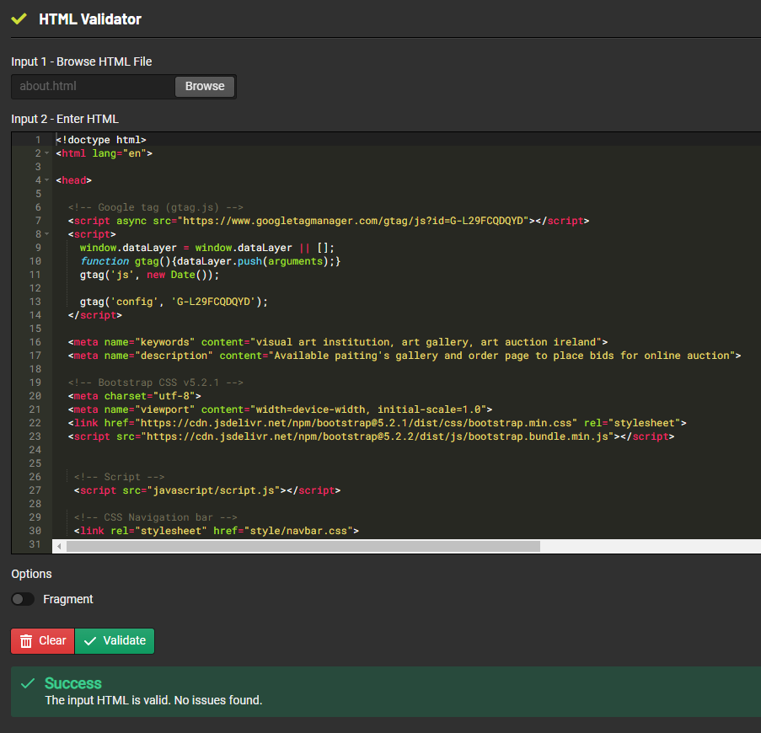

Order Page

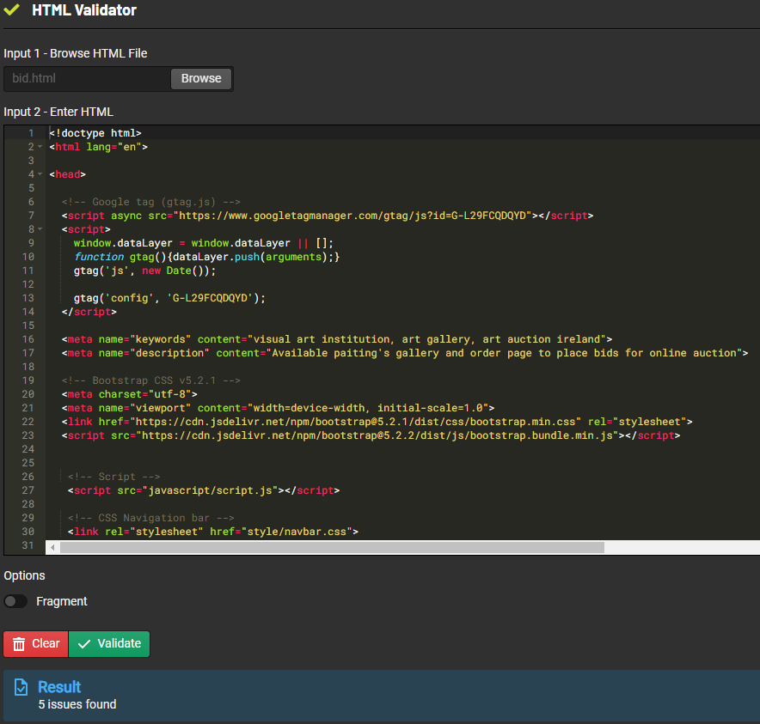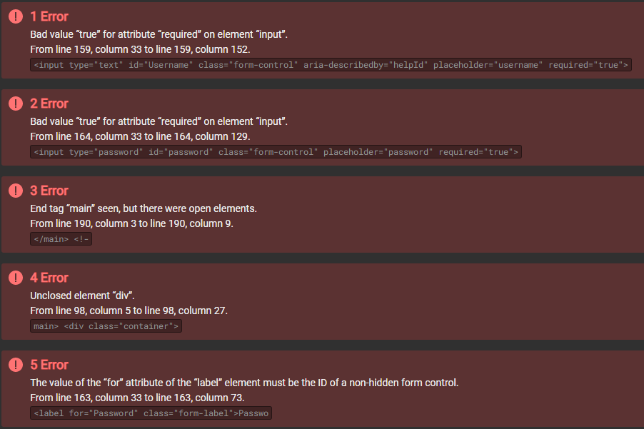

Contact page

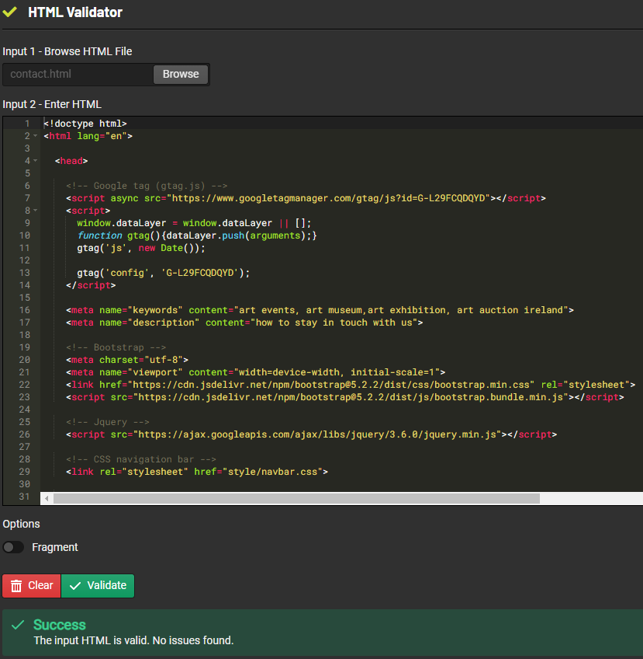

Events Page

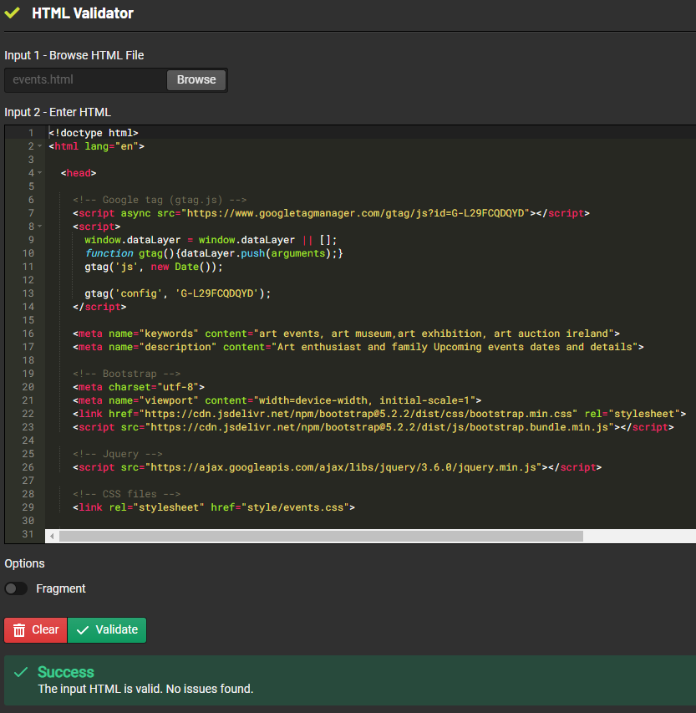

Store page

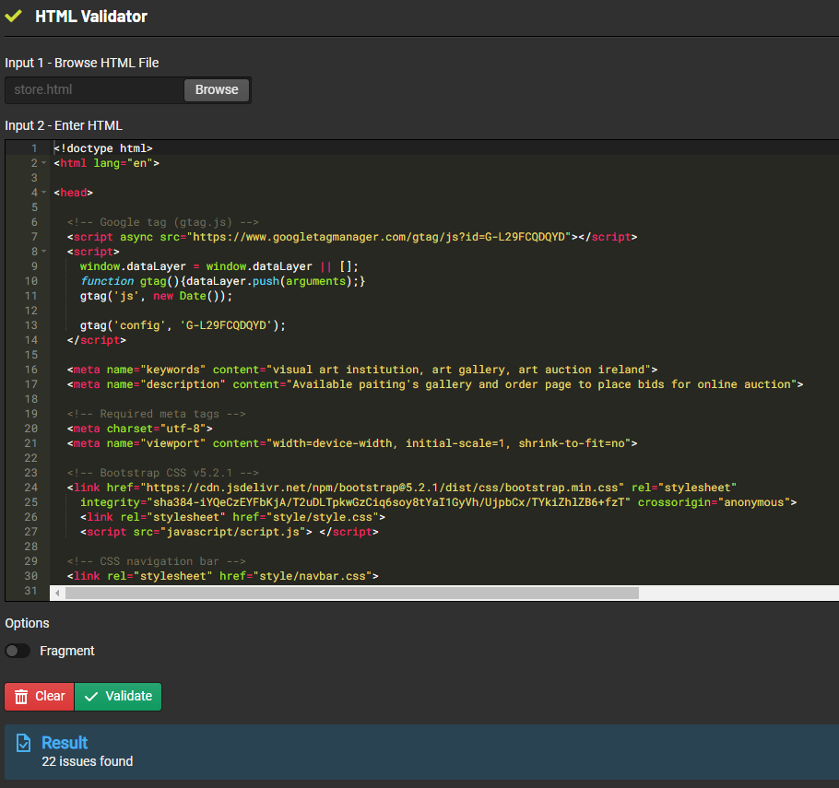

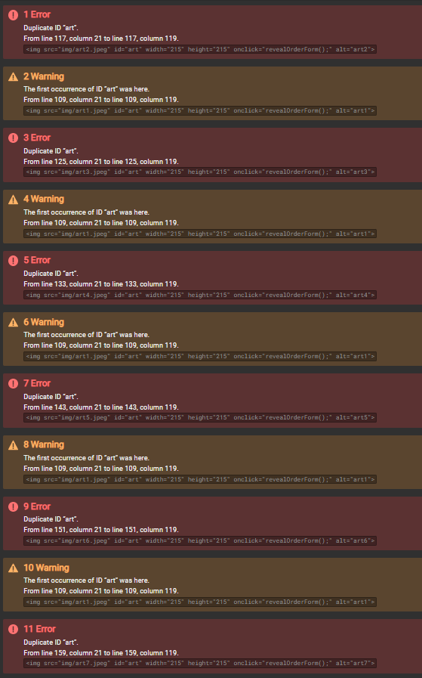

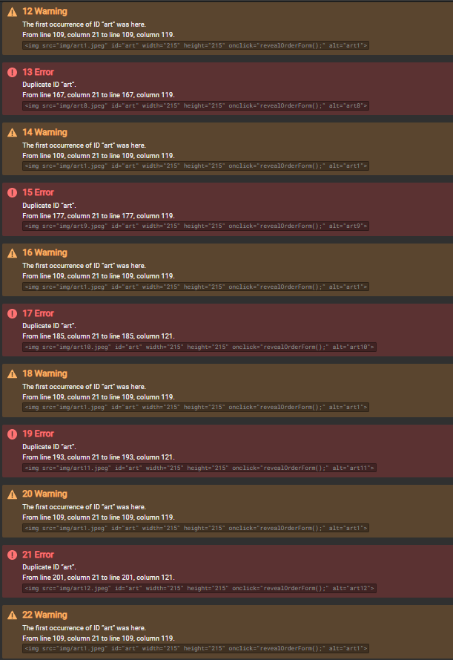

Home page

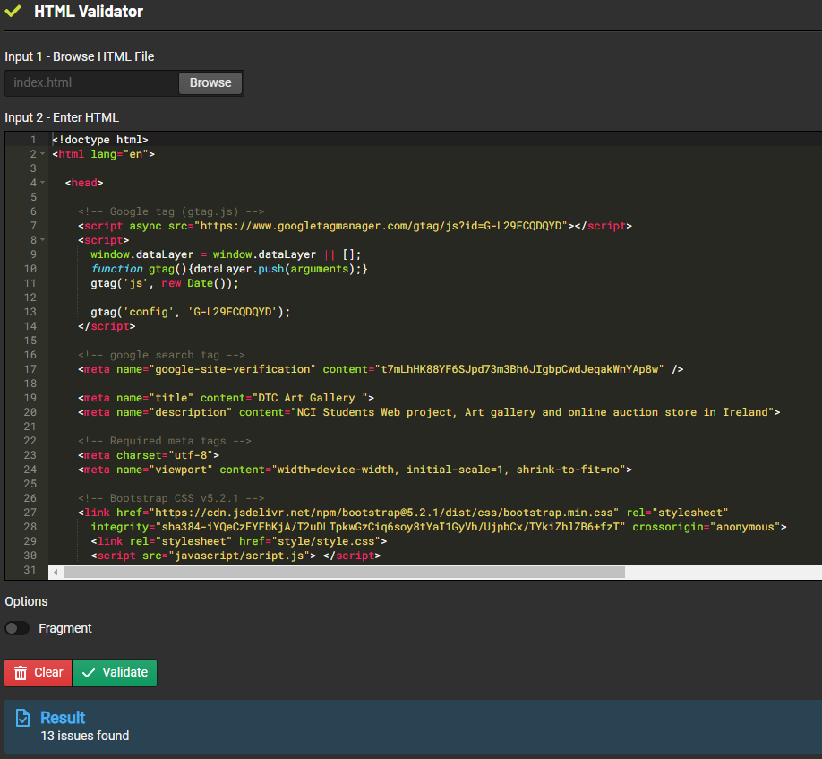

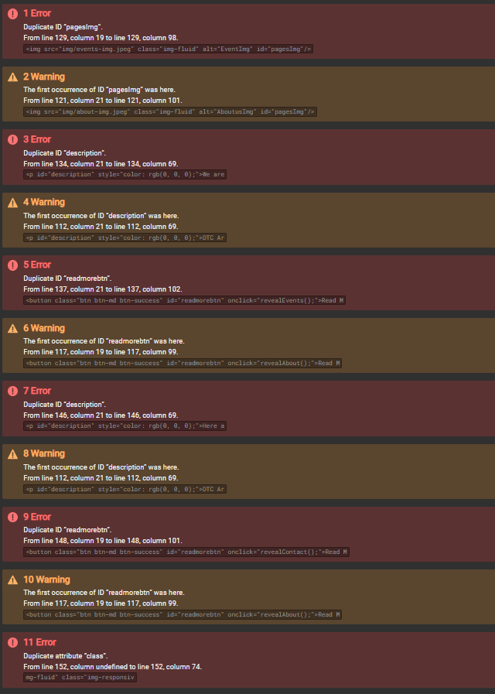

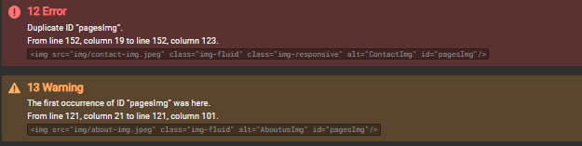

The issues found in some of the pages are not affecting the functionality of the website, however we documented them on the issue log section of this document, so we can fix them in the future.

**Performance, Accessibility, Best Practices and SEO Testing**

We use the PageSpeed Insights tool (<https://pagespeed.web.dev/>) to check any performance, accessibility, best practices, and SEO issues on our pages. The tool checks both desktop and mobile access to the pages.

The tool reported some performance issues in most of the pages, mainly on the Mobile version, however most of the pages scored more than 80%. The issues found were documented on the issue log section of this document, so we can fix them in the future.

Also, we could notice very good results for Accessibility, Best Practices and SEO for most of the pages, in both Mobile and Desktop version.

* Desktop

Home page

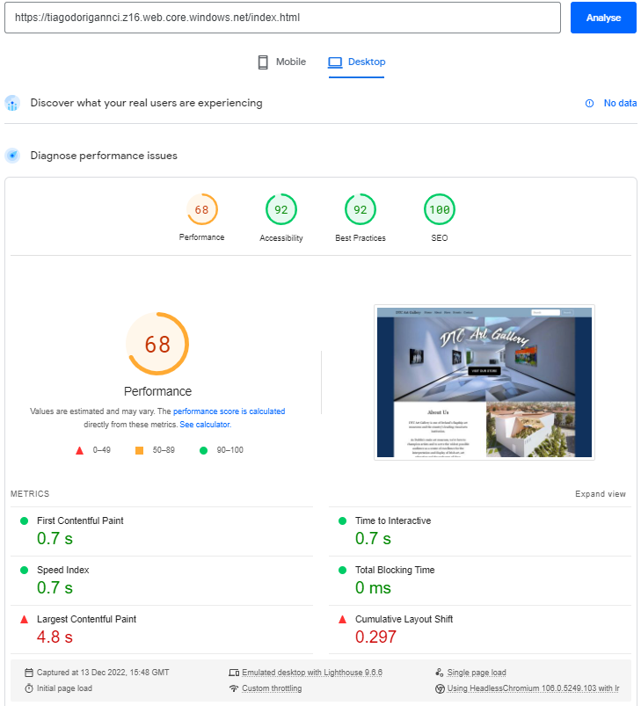

About page

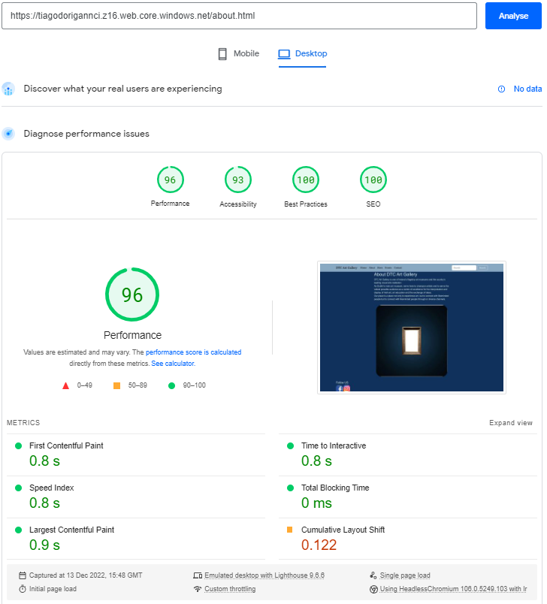

Store page

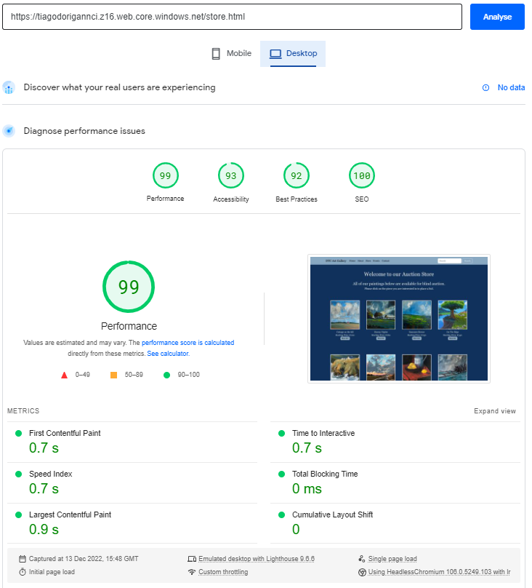

Order page

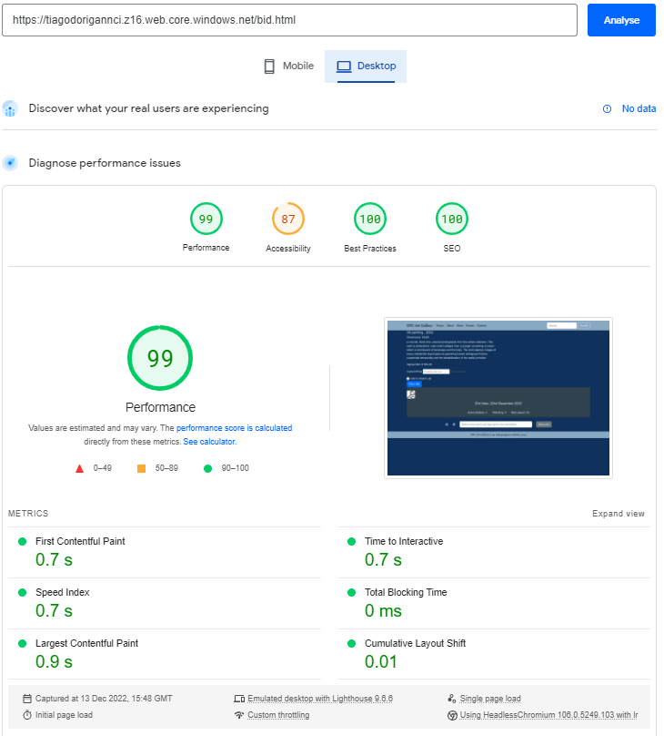

Events page

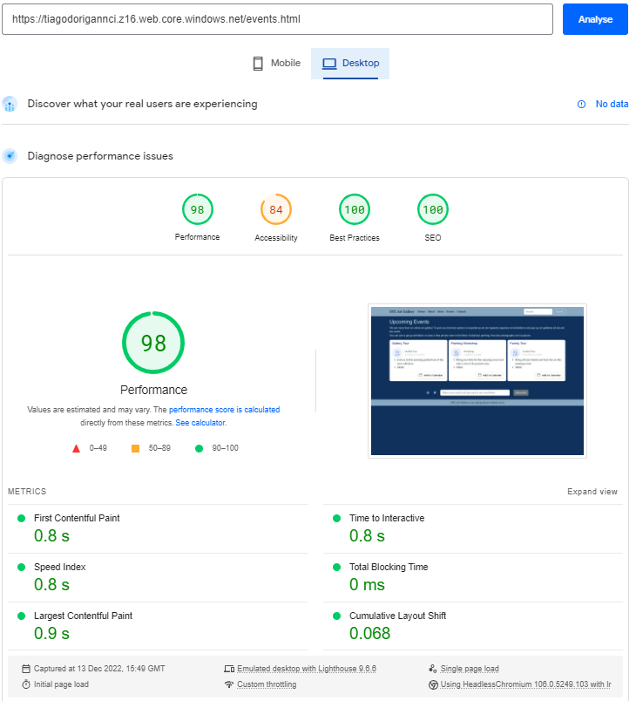

Contact page

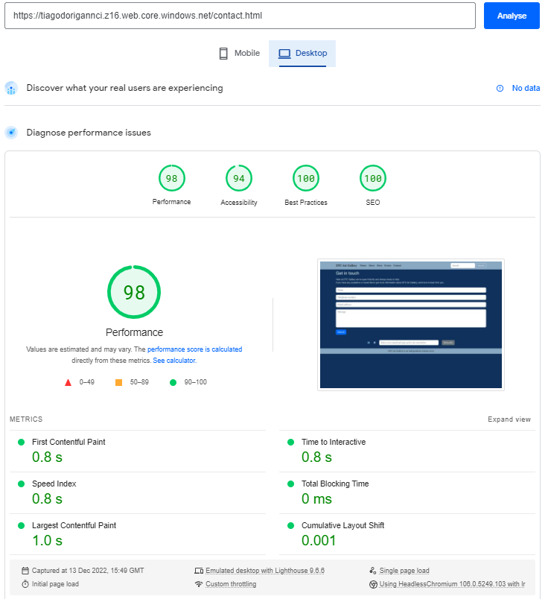

* Mobile

Home page

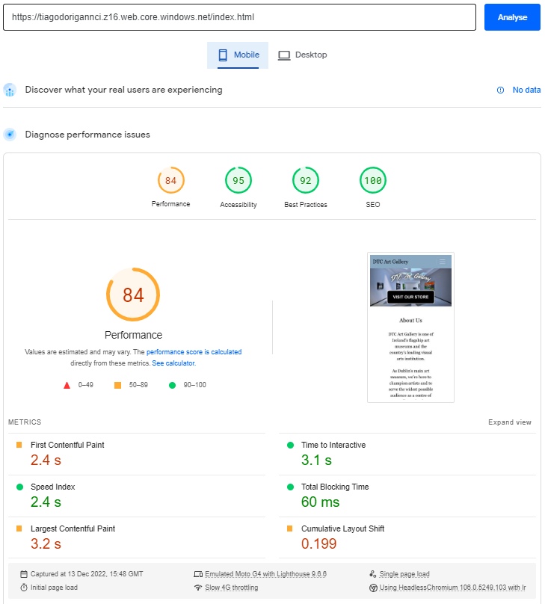

About page

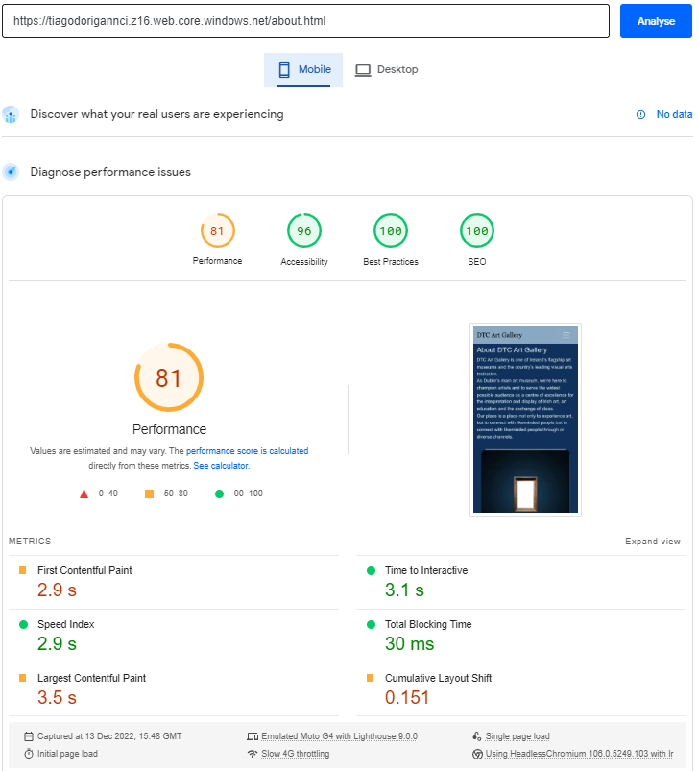

Store page

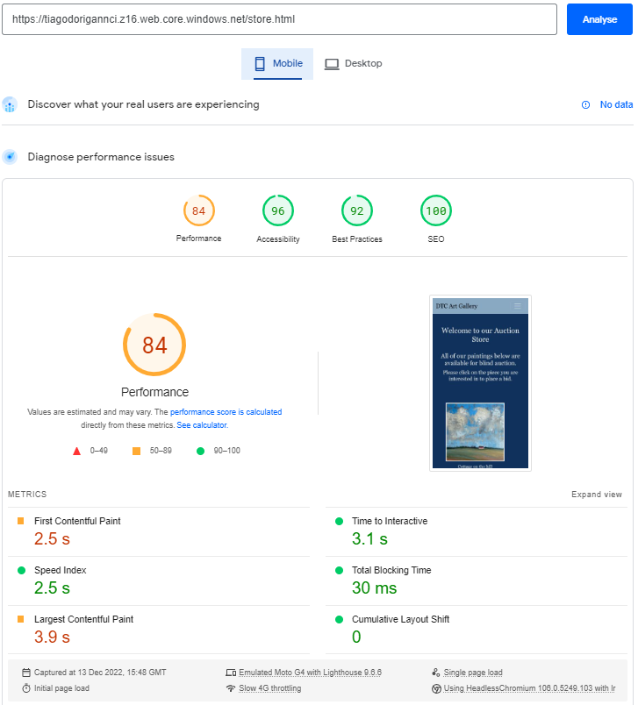

Order page

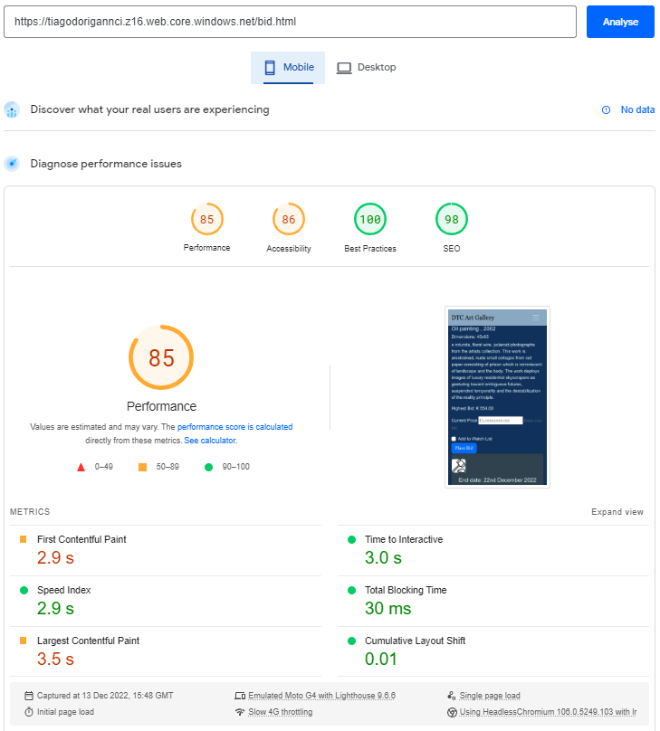

Events page

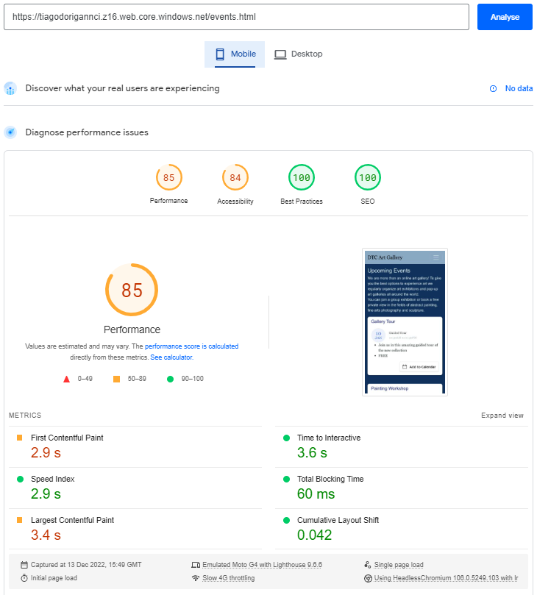

Contact page

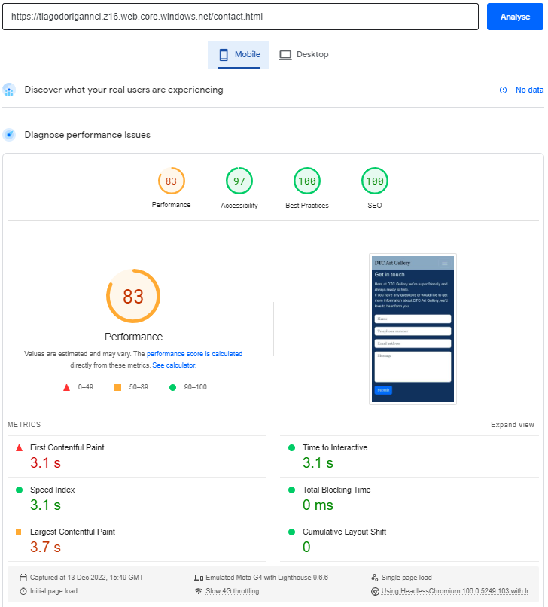

**Functionalities Testing**

* Header

Header section is being shown in the same way in all the pages.

Links have hover effect and are redirecting to the correct pages.

Selected/current page should have different effect (reported on issue log id 14).

Search functionality is out of scope.



* Footer

Buttons are redirecting correctly to the social media pages.

Email is mandatory when clicked on Subscribe button.

Email data type is being validated

Fotter section is being shown in the same way in all the pages.

Subscribe functionality is out of scope.



* Home page

Buttons have hover effect and are redirecting to the correct pages.

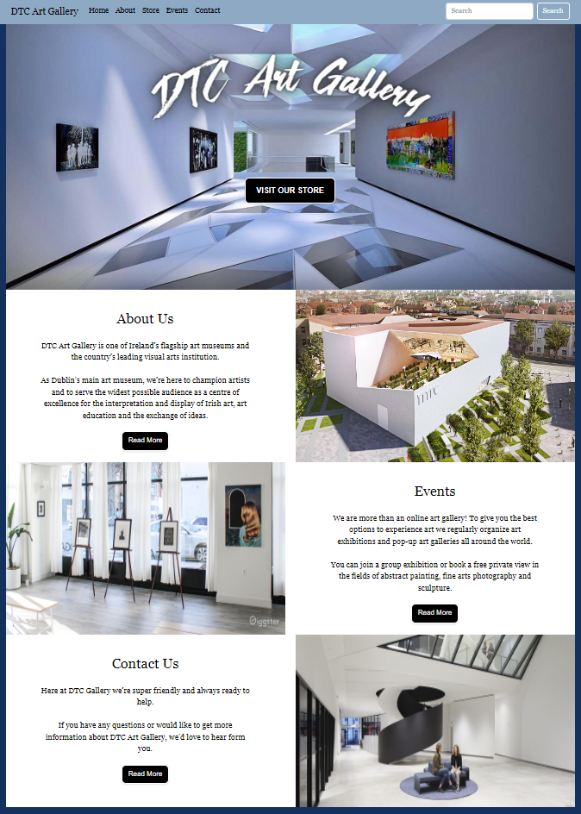

* Store page

Hover effect working on the images.

More Info button working for all images except the last one (is showing information of the first picture (reported on issue log id 13).

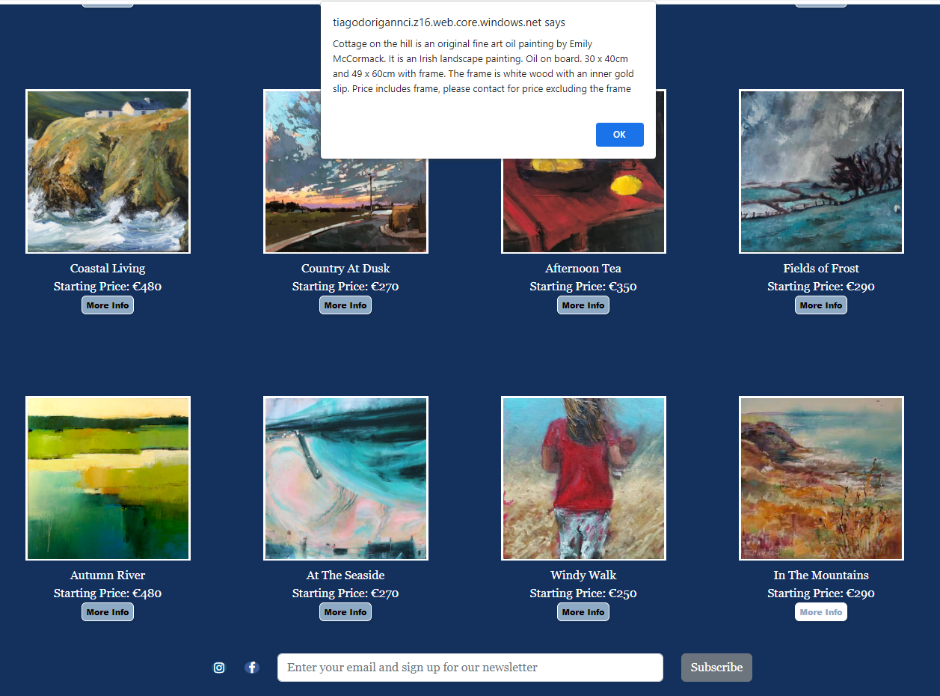

* About page

Information is being shown, buttons have hover effect and are redirecting to social media pages.

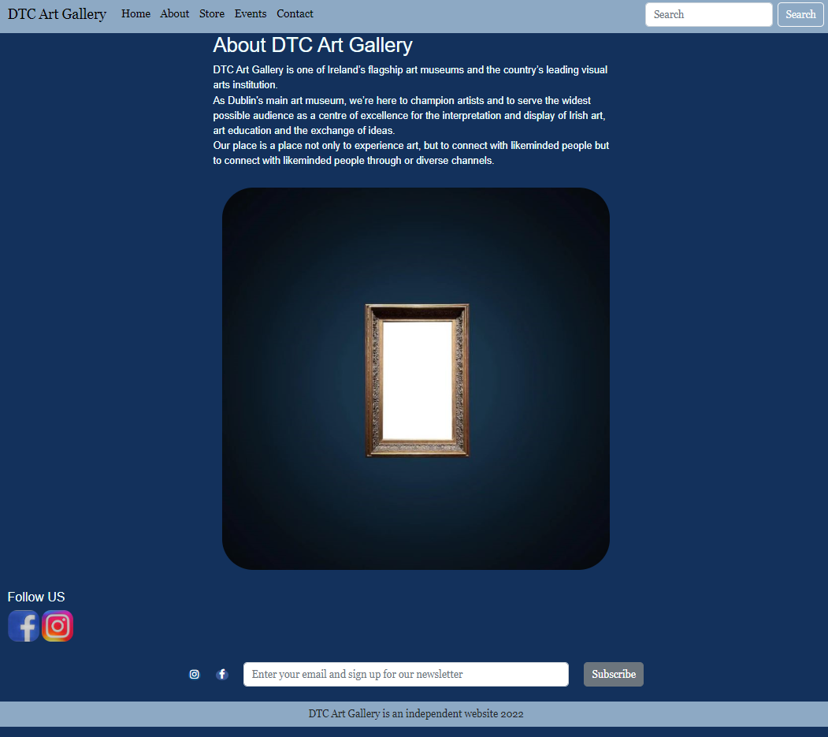

* Order page

Page is being correctly opened in a new window.

Information about the respective image clicked on the store page (window opener) is not being shown (reported on issue log id 15).

Current Price field has no data type and mandatory validation (reported on issue log id 16)

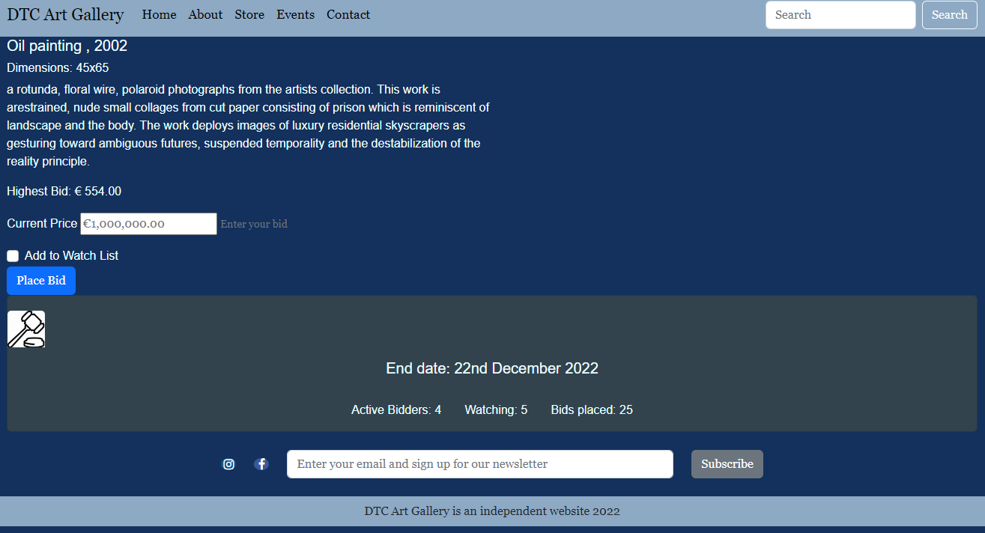

* Events page

Add to Calendar Button is working and redirects to the choose option, creating a new calendar event.

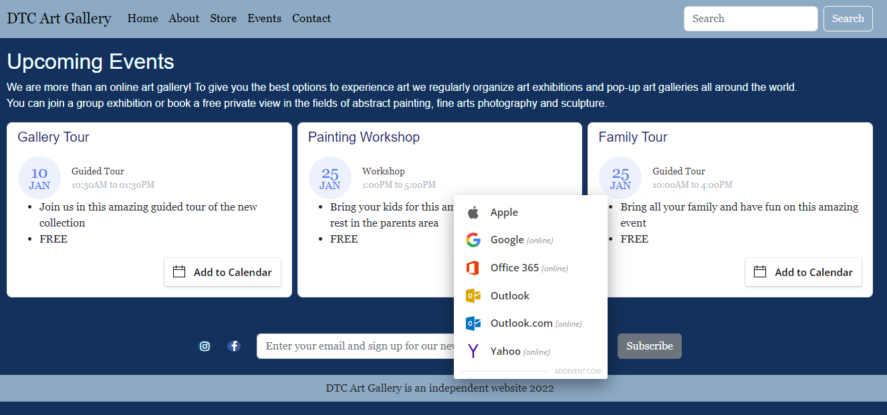

* Contact page

Mandatory fields are being validated before sending the message.

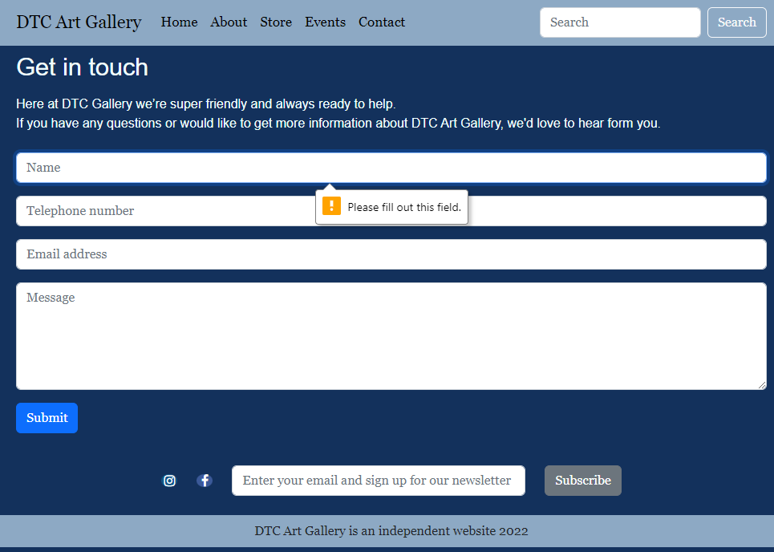

Email field data type is being validated.

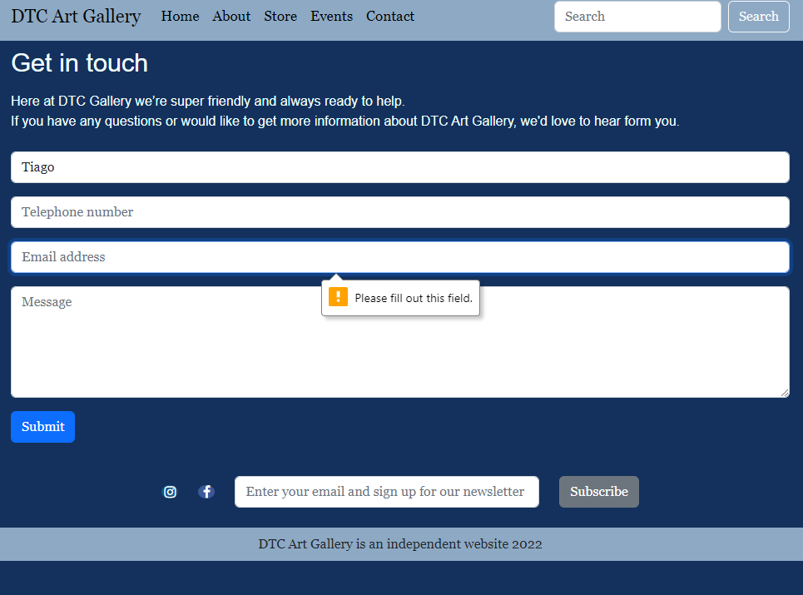

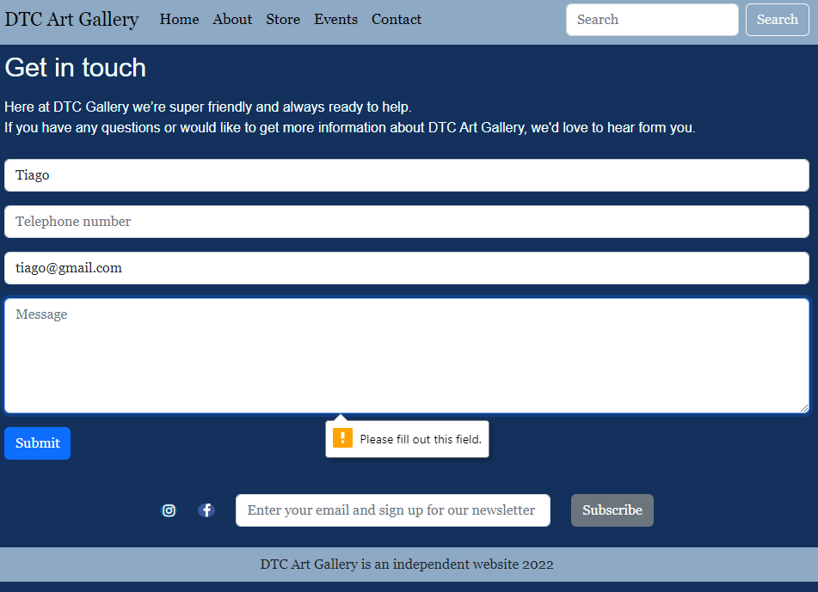

Confirmation option

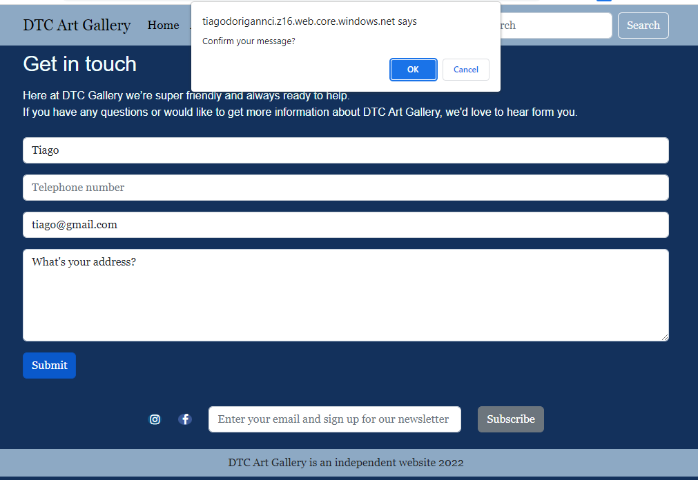

Confirmation message

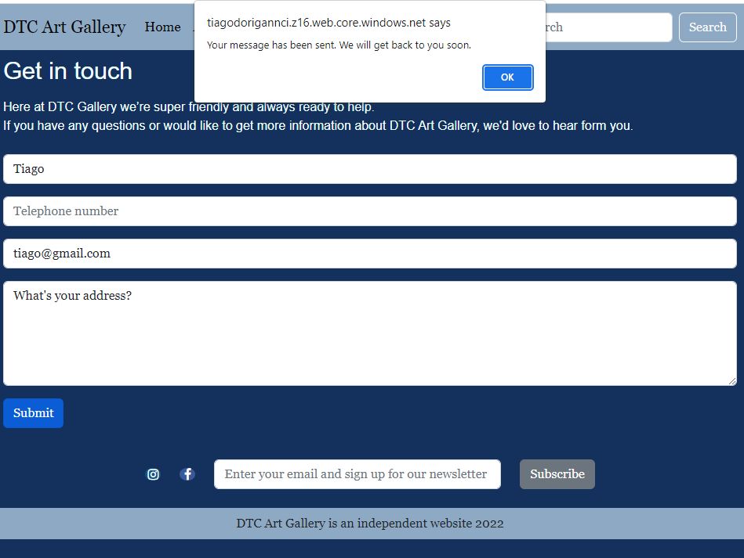

**Issue Log**

In this section we documented all the issues found during the testing process which we were not able to fix because of lack of available time.

|  |  |  |  |
| --- | --- | --- | --- |
| Id | Type | Issue | Status |
| 1 | Performance | Improve Home page mobile and desktop performance | Open |
| 2 | Performance | Improve Order page desktop performance | Open |
| 3 | Performance | Improve Events page desktop and mobile performance | Open |
| 4 | Accessibility | Improve Events page mobile accessibility | Open |
| 5 | Performance | Improve About page mobile performance | Open |
| 6 | Performance | Improve Store page mobile performance | Open |
| 7 | Performance | Improve Order page mobile performance | Open |
| 8 | Accessibility | Improve Order page mobile accessibility | Open |
| 9 | Performance | Improve Contact page mobile performance | Open |
| 10 | Validation | Fix html validator errors for Order page | Open |
| 11 | Validation | Fix html validator errors for Store page | Open |
| 12 | Html Validation | Fix html validator errors for Home page | Open |
| 13 | Functionality | Store page, the last image (In The Mountains) is showing information about the first image instead, when clicked on More Info | Fixed |
| 14 | Functionality | Header - selected/current page should have different effect | Open |
| 15 | Functionality | Order page - information about the respective image clicked on the store page (window opener) is not being shown | Open |
| 16 | Responsiveness | Images on store page overlapping in iPad dimension | Open |
| 17 | Functionality | Footer – No confirmation message when subscribe is clicked | Fixed |

# Conclusion

The team integration was brilliant, everyone was involved and open to suggestions and to help each other. We had daily meetings to check on the work progress and align ideas and expectations.

The most challenging part was to coordinate the alterations done to the source code. We opted for check code alterations using WinMerge tool and upload the files manually. With more time, we could have done it using GitHub tool.

Another challenging part was to make the website to be shown as the first result on google search page. We requested for the pages to be indexed and it took several hours to finish. Initially we used our already existing “tiagodorigannci” storage account on Microsoft Azure, and we requested indexing for that URL. When we created the storage account with the correct name “dtcartgallery” we requested the indexing, but it did not finish before the project deadline, so only “tiagodorigannci” URL is indexed by google. With more time we could have the URL with correct name also indexed by google.

With more time, we could have created a new page called “Partners” where we could link to other group pages and ask them to do the same, so it would improve SEO of everyone involved.

# References

HTML Validator Online - AppDevTools (no date). Available at: <https://appdevtools.com/html-validator>.

About PageSpeed Insights | (no date). Available at: <https://developers.google.com/speed/docs/insights/v5/about>.

AddEvent (no date b). Available at: <https://www.addevent.com/documentation/add-to-calendar-button>

Bootstrap Footer - examples & tutorial (no date). Available at: <https://mdbootstrap.com/docs/standard/navigation/footer/>.

JavaScript Tutorial (no date). Available at: <https://www.w3schools.com/js/>.

Bootstrap 5 Tutorial (no date b). Available at: <https://www.w3schools.com/bootstrap5/>.

Stack Overflow - Where Developers Learn, Share, & Build Careers (no date). Available at: <https://stackoverflow.com/>.

Landscape Oil Painting - The Red Shed Beneath Rolling Clouds (2022). Available at: <https://www.emilymccormack-artist.ie/product/the-red-shed-beneath-the-rolling-clouds-original-oil-painting/>.

Just a moment... (no date d). Available at: <https://www.canva.com/designschool/>.

ARTAuction.online (no date) Online artauction: buy art and sell art online. Available at: <https://www.artauction.online/en/auction/?id=68>.

Free Meta Tag Generator - SEOptimer. (No date b). Available at: <https://www.seoptimer.com/meta-tag-generator>

Google Search Console- Google (no date b). Available at: <https://search.google.com>

Google Ads - Google (no date b). Available at: <https://ads.google.com/>

Google Ads - Google (no date b). Available at: <https://analytics.google.com/analytics/web/>